
www.KSCPM.org

December, 2007
Volume 6, Issue 4
Inside this Issue
1 | - President's Podium  - Amazon.com for last  Minute gift ideas
2 | - 2007 President’s Extra  Mile Award  - KSCPM Fall Luncheon
3 | - It’s a Family Affair  - KSCPM Minutes  December 4, 2007
4 | - 2007 Financial Review  Statement of Cash on  Hand/Balance Sheet
5 | - 2008 Election  - 2007 Gene W. Childress  Leadership Award  - 2007 Charlotte Glaser  Merit Award
6 | -KSCPM Retiree Form
7 | - 2007 Board of Directors

Kentucky Society
The Cutting Edge
Sharpening Your Management Skills through KSCPM

Certified Public Managers®

Looking for last minute gift ideas?



Why not help the American Academy of Certified Public Managers® when you shop? It's easy. All you have to do is enter the Amazon.com website through the Academy's website, www.cpmacademy.org. Then, for every purchase you make, the Academy earns a 5% bonus through Amazon's Associates Program.

Will you be retiring in 2008? Be sure to keep a copy of the form on page 6.

President's Podium
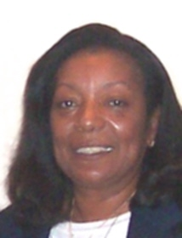

It seems like only yesterday that our board team began our year in service. It has been an honor being President of the Kentucky Society of Certified Public Managers® this year and I thank you again for making it possible. I am grateful to the KSCPM who demonstrated so many times this year their support and loyalty to not only me but the AACPM. This made possible my (4) years of Academy service as Member-at-Large/Member Affairs to its members, and its state societies. Trust me, I could not have done it without you!

KSCPM was well represented in the leadership of the Academy in 2007.
Seven Board members attended the 19th Annual Professional Development Conference in Madison, WI and six members served on nine different committees.

I would encourage members to view the updated KSCPM history with the year in review, and Wisconsin conference photos that will be posted to our website after the first of the year.

Now, it's time to remind others to volunteer and continue volunteering their leadership skills, time, and talents in service. I encourage you to volunteer and serve on the many committees needed to maintain a successful operating level of the KSCPM, everyone has something to contribute. We look forward to working with the new administration in 2008 as the KCPM program moves forward to build and maintain a core of skilled and knowledgeable leaders to direct, manage and supervise employees, programs, and projects in the public sector in Kentucky.

Robinil H. Jameson, CPM
President, KSCPM



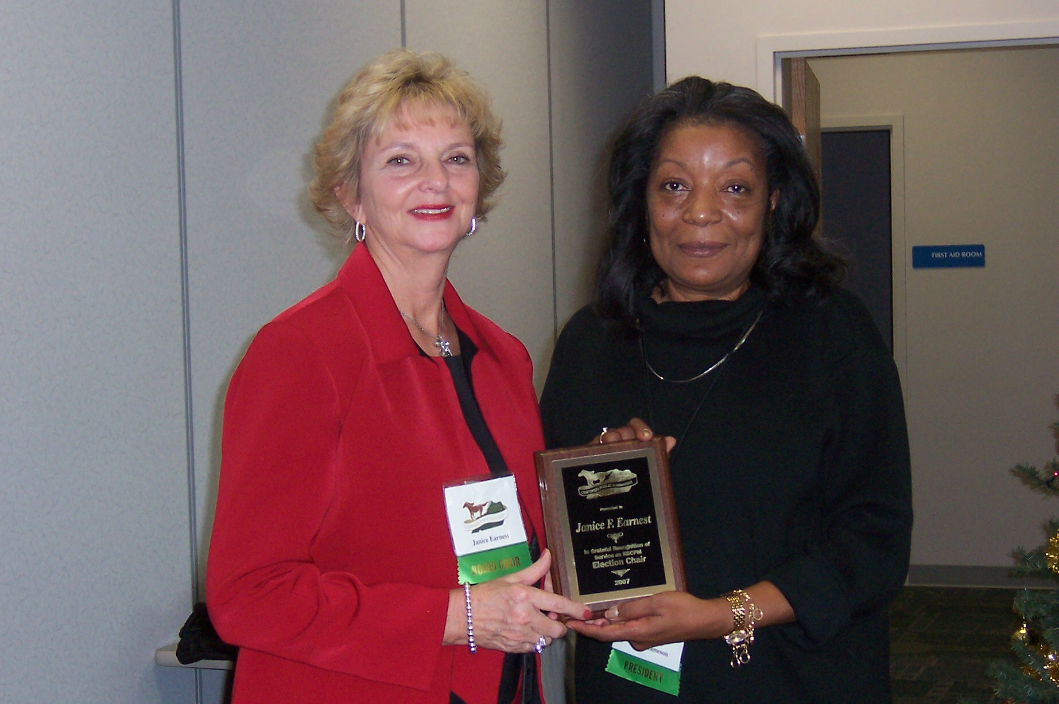
Janice Earnest receives the President’s Extra Mile Award

President’s Extra Mile Award

This award is intended to recognize those individuals who have “gone the extra mile” in a specific situation and who deserve an extra pat on the back for their outstanding performance of duties. Janice helped the President to coordinate chapter, events and activities and basically “made things happen when it looked like they would not happen.”
Commissioner Greg Howard Addressed
Attendees at Fall Luncheon
by
Janice Earnest, CPM

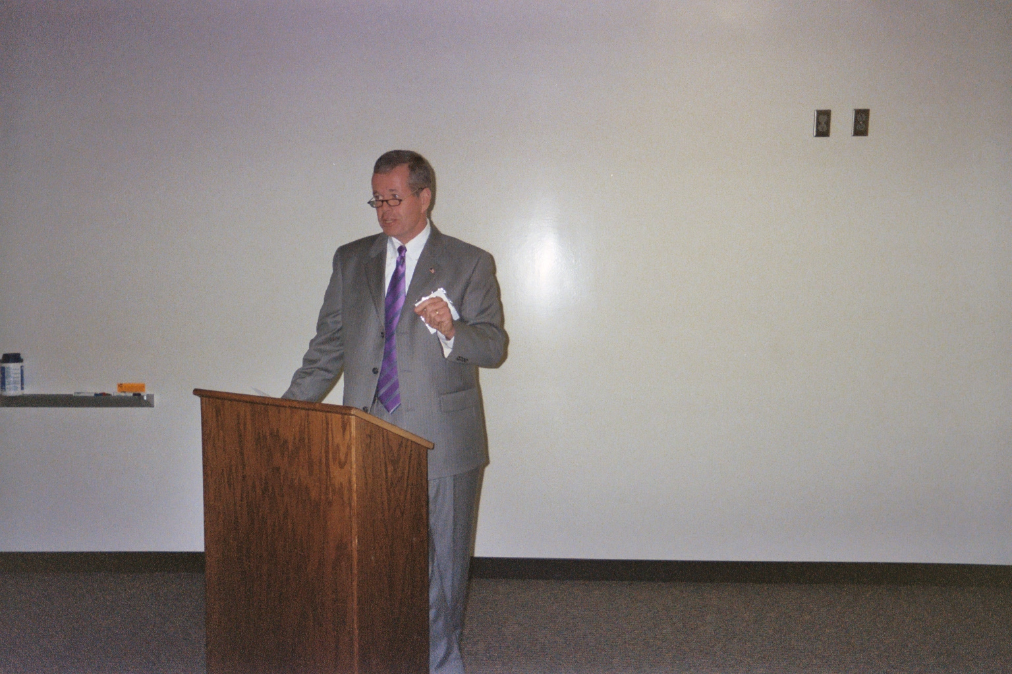

KSCPM members recently enjoyed a presentation about being successful in life given by Kentucky Vehicle Enforcement Commissioner Gregory G. Howard. Commissioner Howard was the speaker for the Fall Luncheon on October 22 at the Kentucky Transportation Building in Frankfort.

Commissioner Howard listed Ten Things To Be Successful:

- Invest in your people – show that you care about them
- Have no personal agenda – humbleness is God-given
- Live a live of integrity (faith, family, work)
- Career Development – seek all the training you can get
- Make sure that you have a department-wide view (how it affects things)
- Accept a clash of ideas – challenge everyone to have input
- Being a leader is not a popularity contest. Be available, make decisions, stay connected, but you don’t have to be a mean person.
- Be the spark. Have the best attitude—choose joy.
- Personal fitness and wellness – food, spiritual life, mental life.
- Don’t make decisions when you’re mad.

He added that you should embrace change—change creates growth. Believe in the people that work for you.
It’s A Family Affair!

Did you know that among the KSCPM membership, we have several people who are related to each other? Some members are the 2nd generation of their family to complete the program and join the Society.

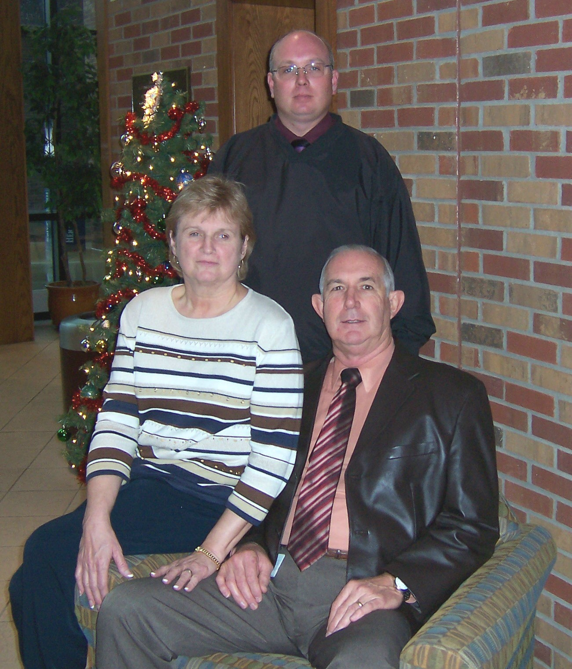

Betty, Ron and Ande Godsey

From the Godsey family, we have Betty, Ron and Ande (mother, father and son). Ken Schwendeman, has always been a big supporter and encouraged others to join, including his brother Mike. Husband and wife, Art and Mary Pascal have been members for several years.

Our 2008 President Tony Smith and his wife Susan are long-time members who have both served the Society as President and held other offices.

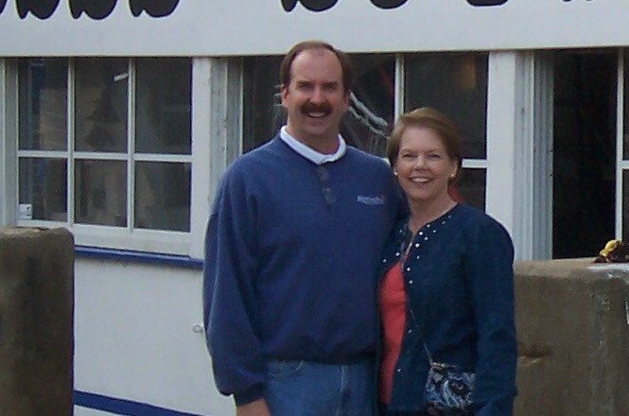
Tony and Susan Smith

Sisters-in-law Helen Koger and Janice Earnest became members in 2002. When Janice’s son Patrick Brown became a state employee a few years later, they encouraged him to begin the CPM program and join the Society.
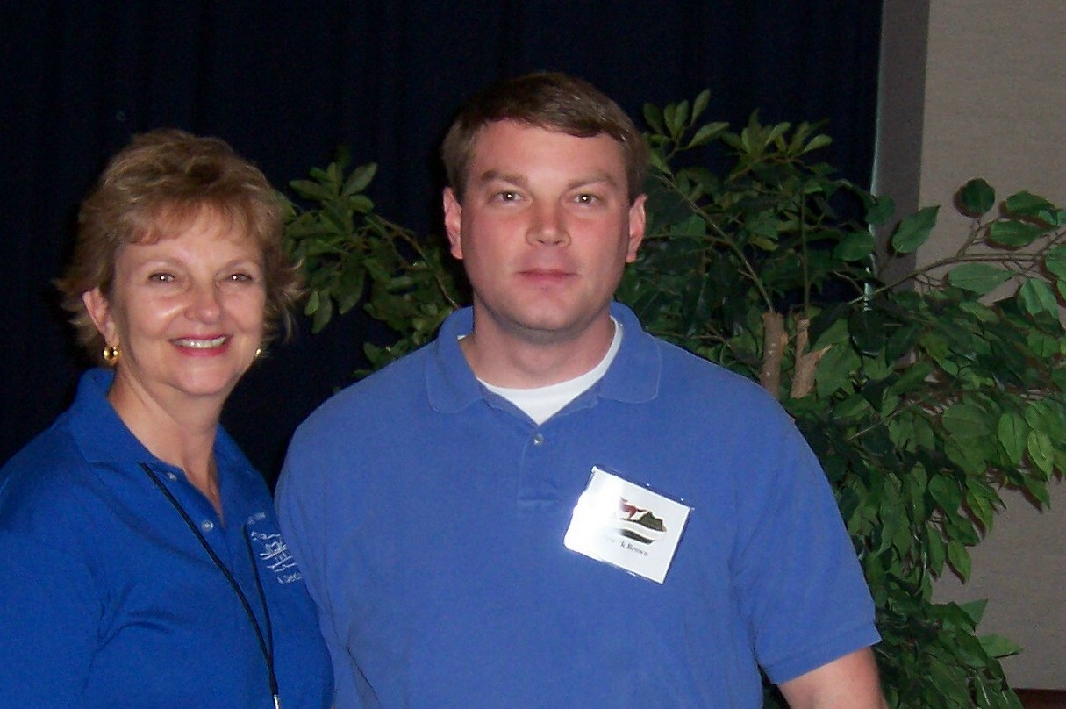
Janice Earnest and Patrick Brown

I’m sure there are other families who have more than one Society member. It just goes to show that this is an excellent organization that you would want to recommend to those closest to you.


Minutes of KSCPM Election/Awards Luncheon and Board Meeting
Tuesday December 4, 2007
11:30am – 1:00pm

Election/Awards Luncheon and Board Meeting, held at the KHEAA Building, Frankfort.

Board Members present were: Robinil Jameson, Tony Smith, Helen Koger, Jeanne Olivas, Janice Earnest, Katy Cave, Rebecca Conley, and Sherman Bowman. Approximately 23 other KSCPM members attended.

President Robinil Jameson called the meeting to order. The Election Committee was excused to count votes for the 2008 officers.

The first item of business was the Minutes from the last Board meeting. A motion was made by Sherman Bowman to accept the Minutes. The motion was seconded and carried.

The motion was made by Tony Smith and seconded by Meryl Begley to accept the Financial Report provided by Committee Chair Robert Armstrong. Motion carried.

Past presidents attending the Board meeting were recognized. They were Susan Smith, Pat Bryan, J. R. Brown, and Glenn Thomas.
The Election Committee reported on the election. Winners were: President-Elect, Sherman Bowman, Secretary, Katy Cave and Treasurer, Carmen Bishop.

Recognitions/Awards Presented:

- J. R. Brown was the Henning Nominee from Kentucky
- Patrick Brown was the Wilkinson Scholarship winner from Kentucky
- Laura Lynn Best was the 2007 KSCPM Askew winner for the top project. President-Elect Tony Smith presented Ms. Best with the AACPM Askew medallion.
- Carmen Bishop was the Charlotte Glaser award winner.
- Tony Smith was presented the Gene Childress Leadership Award.
- Janice Earnest received the President’s Extra Mile Award.
- All Board members were presented a plaque by President Robinil Jameson for their service during 2007.

President Jameson presented the 2007 Board of Directors. Tony Smith, President Elect; Helen Koger, Secretary; Carmen Bishop, Treasurer; Jeanne Olivas, GSC Liaison; Katy Cave, Program Chair and Brenda Crossman Committee Member; Doug Holt, Publications; Bob Armstrong, Finance Chair; Sherman Bowman, Legislative Chair; Rebe Conley, Membership Chair; Janice Earnest, Historian/Archivist and Election Chair.

Tony Smith moved to destroy last year’s election ballots. The motion was seconded and passed.

Meeting was adjourned at 1 p.m.

Minutes submitted by Helen Koger, 2007 KSCPM Secretary

FINANCIAL REVIEW
2007

To the Board of Directors:

I have reviewed the checkbook, bank statements, deposits, and receipts on record as submitted by the Treasurer of the Kentucky Society of Certified Public Managers.

I have found the Treasurer’s records to be in balance with the Farmers Bank & Capital Trust bank statements and receipts on record for expenses incurred. All expenses were approved by the Board of Directors and/or recorded in the minutes of the Board Meetings.

Attached is a Statement of Cash on Hand, as well as a Balance Sheet as of November 20, 2007.

Respectfully Submitted,
Robert Armstrong, CPM
Finance Chair

STATEMENT OF CASH ON HAND
November 20, 2007

Beginning Cash on Hand, January 1, 2007 $10,897.68
Income YTD 5,974.50
Expenses YTD 5,291.40
Less Purchase of 2 Certificates of Deposit 4,000.00

Ending Cash on Hand, November 20, 2007 7,580.78

BALANCE SHEET
November 20, 2007

ASSETS

Cash, Farmers Bank & Capital Trust Checking $7,580.78
Certificates of Deposit (same bank) 4,071.05
(amount includes capitalized interest on 1 CD)

Total Assets: 11,651.83

LIABILITIES $0

NET WORTH $11,651.83
Election of 2008 Officers
By
Janice Earnest, CPM
Elections Chair

It’s official! Sherman Bowman is President-Elect; Katy Cave is Secretary; and Carmen Bishop begins a third term as Treasurer for 2008. Sixty people returned their ballots and cast a vote for the candidates running for offices. The ballots were opened and recorded at the annual Election/Awards luncheon on December 4.

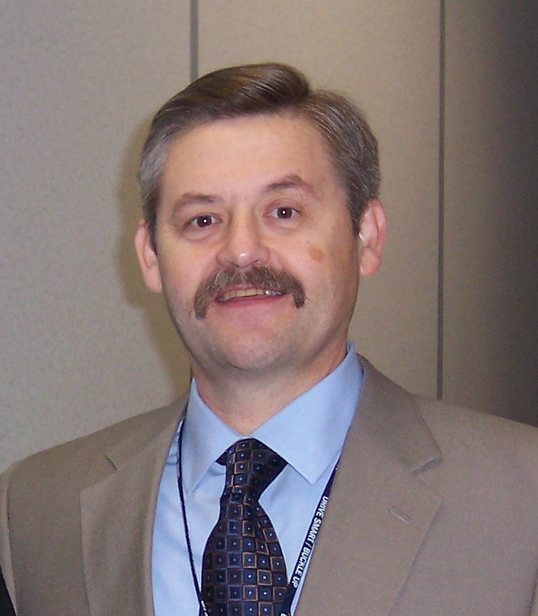
Sherman is a Program Coordinator with the Kentucky Transportation Cabinet, Department of Vehicle Regulation. He has served four years on the KSCPM Board and chaired the Program and Legislative Committees.

.

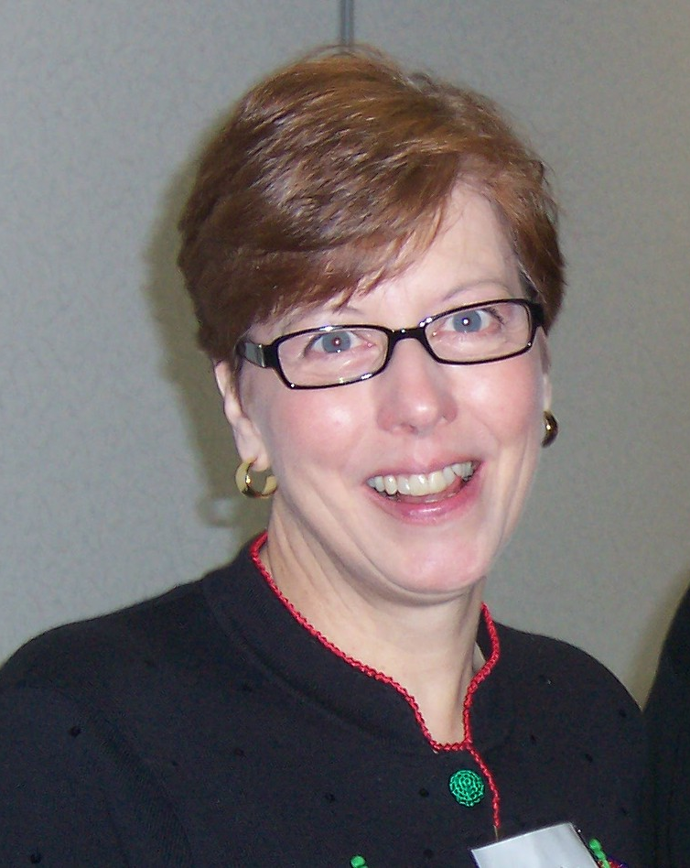
Katy is a Trainer for Governmental Services. She has both teaching and secretarial experience and in 2007 served on the Board as Program Chair.

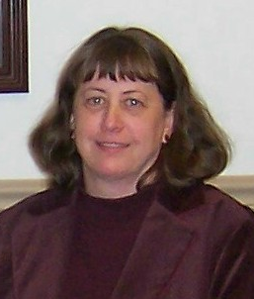
Carmen has 21 years of experience with the Kentucky Office of Financial Institutions. She has served on the Board two years as Secretary and two years as Treasurer, including serving as Treasurer for the AACPM Conference in 2006 when Kentucky hosted.

Along with President Tony Smith, who begins his third term as President, (with breaks in between) we have a good team to lead the Society forward.
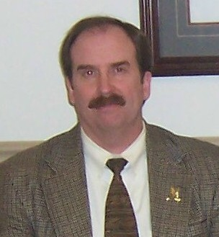
2007 Gene W. Childress
Leadership Award

The 2007 Gene W. Childress Leadership Award was presented to Tony Smith. For over 26 years, Tony has been the model state employee. He is currently the Transportation Cabinet’s quality review inspector and holds the title of Staff Assistant. He is the only CPM to have served as President of the Kentucky Society of Certified Public Managers® for three terms. In addition to his lengthy resume of outstanding achievements, enduring leadership, caring management, and innovative approaches to the improvement of state government, he has continued his personal journey of learning.

As a supervisor and branch manager, he has mentored numerous employees and coached more than a few in their pursuit of CPM certification over the years. Tony’s legacy of improved management procedures, new operational policies, and personal friendships will outlast his tenure as a state employee, but his advocacy of the CPM program will not only leave a lasting impression, but will also serve as an example to others.

2007 Charlotte Glaser
KSCPM Merit Award

The 2007 Charlotte Glaser KSCPM Merit Award was presented to Carmen Bishop. Carmen exemplifies the standards set forth for the Charlotte Glaser Award. She has demonstrated an exceptional level of service to the KSCPM by serving as Secretary in 2004 and 2005, Treasurer in 2006 and 2007, and especially her expert handling of the funds for KSCPM when we hosted the AACPM Conference last year.

She used her skills to create and maintain a KSCPM scrapbook depicting events of our Society from its beginning up to the present time and created items for the display board used at the Conference registration and at Society events. Carmen has worked hard and contributed greatly to the successes of our Society, not only this year, but since she became a member.

RETIREES

Kentucky Society of Certified Public Managers®



Name___________________________________________________________________________________________________

Date Retiring ___________________________________________________________________

Address________________________________________________________________________

City________________________________State____________________Zip________________

Telephone_________________________________Fax__________________________________

E-mail_________________________________________________________________________

____________I do want my name and home address in the membership directory
____________I do NOT want my name and home address in the membership directory

Mail to: | E-Mail to:
KSCPM  POB 42  Frankfort, KY 40602-0042 | Tonyb.smith@ky.gov  -OR-  carmen.bishop@ky.gov

Please notify us at least (2) weeks prior so we can change information in the database.

Must be a current KSCPM member in good standing.

KSCPM 2007 BOARD OF DIRECTORS

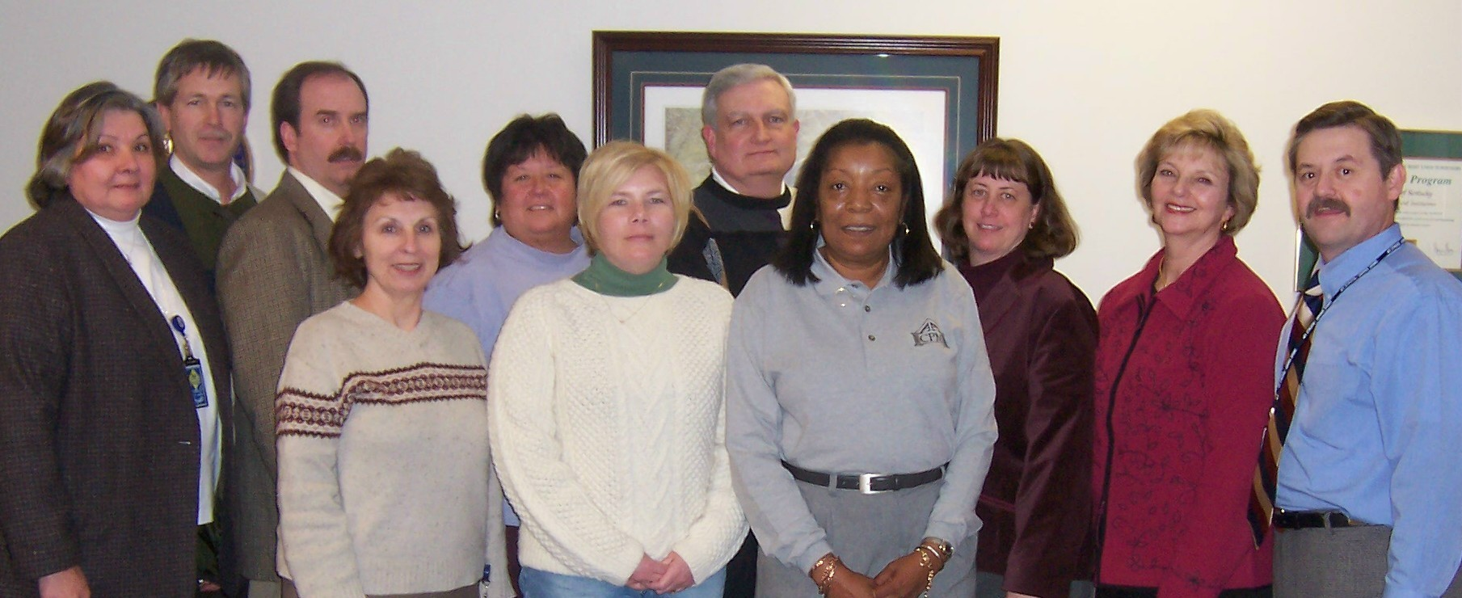
(L-R) Brenda Crosman, Robert Armstrong, Tony Smith, Helen Koger, Jeanne Olivas, Rebecca Conley, Larry Totten, Robinil Jameson, Carmen Bishop, Janice Earnest, Sherman Bowman (Absent from photo: Katy Cave, Pamla Wood.)

Robinil H. Jameson | President | RHJCPM@aol.com | 502-875-5466
Tony Smith | President-Elect | tonyb.smith@ky.gov | 502-564-3040
Helen Koger | Secretary | helen.koger@ky.gov | 859-622-3801
Carmen Bishop | Treasurer | carmen.bishop@ky.gov | 502-573-3390
Larry P. Totten | Immediate Past President | larry.totten@ky.gov | 270-343-2449
Jeanne Olivas | OEOD Liaison | jeanne.olivas@ky.gov | 502-564-8170
Janice Earnest | Election Committee | janice.earnest@ky.gov | 859-622-8062
Katy Cave | Program Committee | Katy.cave@ky.gov | 502-564-8170
 | Publications & Publicity Committee
Rebecca Conley | Membership Committee | rebecca.conley@ky.gov | 502-573-3390
Robert Armstrong | Finance Committee | robert.armstrong@ky.gov | 502-245-9091
Larry P. Totten | Awards Committee | larry.totten@ky.gov | 270-343-2449
Special Appointed Committees
Sherman Bowman | Legislative Committee | sherman.bowman@ky.gov | 502-564-7000  Ext. 4172
Janice Earnest | Historian & Archivist | janice.earnest@ky.gov | 859-622-8062
Janice Earnest  Robinil H. Jameson | Standard Operating Procedures | janice.earnest@ky.gov  RHJCPM@aol.com | 859-622-8062  502-875-5466
KSCPM | Web Page | http://www.KSCPM.org | POB 42  Frankfort, KY  40602-0042
AACPM | Web Page | http://www.cpmacademy.org

The Cutting Edge  KSCPM Newsletter  P. O. Box 42  Frankfort, KY 40602-0042 |  | POSTAGE
ADDRESS CORRECTION REQUESTED

