
www.KSCPM.org

September, 2007
Volume 7, Issue 3
Inside this Issue
1 | - KSCPM Fall Luncheon  - President's Podium
2 | -2007 AACPM Conference  Photos  - 2007 Conference Note  From 1st time Attendee
3 | - KSCPM Summer  Luncheon  - 2008 Election Update
4 | - 2007 KSCPM Henning  Nominee Profile JR Brown
5 | - 2007 AACPM Wilkinson  Recipient Patrick Brown
6 | - Annual Awards Update  - Minutes - March, 2007  Board Meeting
7 | - Treasurer’s Report
8 | -Childress Nomination Form
9 | -Glaser Nomination Form
10 | - Dates to Remember
11 | - 2007 Board of Directors

Kentucky Society
The Cutting Edge
Sharpening Your Management Skills through KSCPM

Certified Public Managers

KSCPM FALL LUNCHEON

Gregory G. Howard
Commissioner
Kentucky Vehicle Enforcement

Monday, October 22, 2007

Kentucky Transportation
Building – C117

FRANKFORT, KY

President's Podium

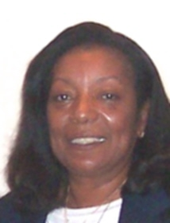

For members unable to attend the 19th Annual AACPM Professional Development Conference, let me say the quality of the programs was balanced beautifully by the warm weather and social activities each evening. From the opening ceremony held in the Assembly Chamber at the Capitol Building when President-Elect Tony Smith carried the Kentucky flag, to the Awards Banquet where KSCPM’s Patrick Brown was Kentucky’s first Wilkinson Scholarship winner, we were well represented.

As the Certified Public Manager® program continues to grow; we have had a major emphasis in 2007 on marketing and benefits. In addition to an electronic subscription to The Public Manager magazine, member discounts for Daly computers and Corel software, and license plate frames to further promote the organization, members were excited to learn of the AACPM travel website.

In 1996, when experienced and dedicated KSCPM members hosted their first AACPM conference, a tradition was born - Society baskets as door prizes to represent the States’ products. In 2003, South Carolina raffled the Society baskets with the proceeds going to the next state hosting the conference. In 2006 KSCPM members started what they hoped would be another tradition, offering a discounted rate to retired AACPM members. This year the Wisconsin Society of Certified Public Managers® offered the same discounted registration fee. KSCPM members were still receiving compliments on the 2006 conference held in Louisville and we noticed several of last year’s conference tote bags were in use this year. The KSCPM has maintained a long and rich heritage of excellence. Today we continue that tradition as we apply ourselves to an important goal, strengthening our emphasis on scholarship and culture.

Robinil H. Jameson, CPM
President, KSCPM

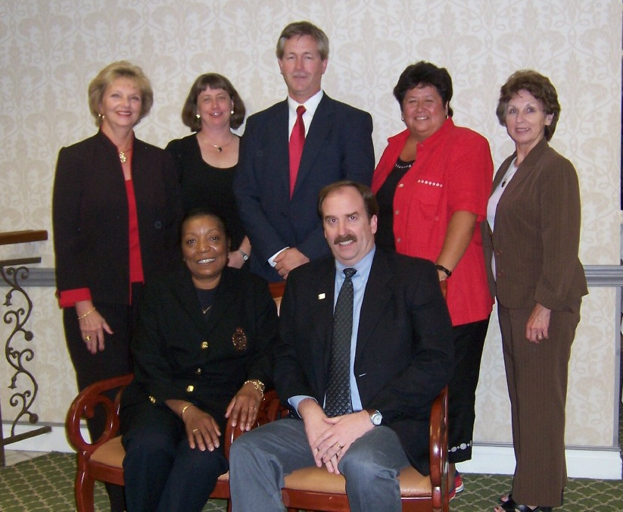
Seated: Robinil Jameson, Tony Smith Standing: Janice Earnest, Carmen Bishop, Robert Armstrong, Jeanne Olivas, Helen Koger

KSCPM 2007 AACPM Conference Attendees

- Robinil Jameson/President
- Tony Smith/President-Elect
- Helen Koger/Secretary
- Carmen Bishop/Treasurer
- Jeanne Olivas/GSC Liaison
- Janice Earnest/Election Committee Chair
- Robert Armstrong/Finance Committee Chair
- Robert Brown
- Todd Bailey
Awards/Recognitions

KSCPM Askew Award Winner – Laura Lynne Best
KSCPM Henning Nominee – James R. Brown
AACPM Wilkinson Scholarship Recipient – Patrick Brown

AACPM Conference Note
Bob Armstrong, CPM
Securities Examiner

Hello to all fellow AACPM members. It has been a week now since our return from the 19th annual conference recently held in Madison, Wisconsin. For many of you, this conference has become an annual event and an opportunity to visit with old friends and share stories of recent experiences. As a first time attendee I did not really know what to expect. After the initial shock of the colorful name tags faded, and as I watched you “veterans” interact with each other, I noticed that while you may be from very distant parts of this country and have very different professions, there is a common thread that joins you together. Many of you face the same daily challenges within your work unit. Do more with less, do things faster, do it better, stay under budget, working with untrained (if not incompetent) staff, etc….I have a tendency to be one of those “big picture” kind of guys. As I look back at my first conference it is clear that the opportunity for diverse public leaders to converge and bounce ideas off each other is priceless. It can only serve to make our governments better.

Thank-you all for making the conference such a positive experience for this “rookie”. I hope to see you all next year in OH io!

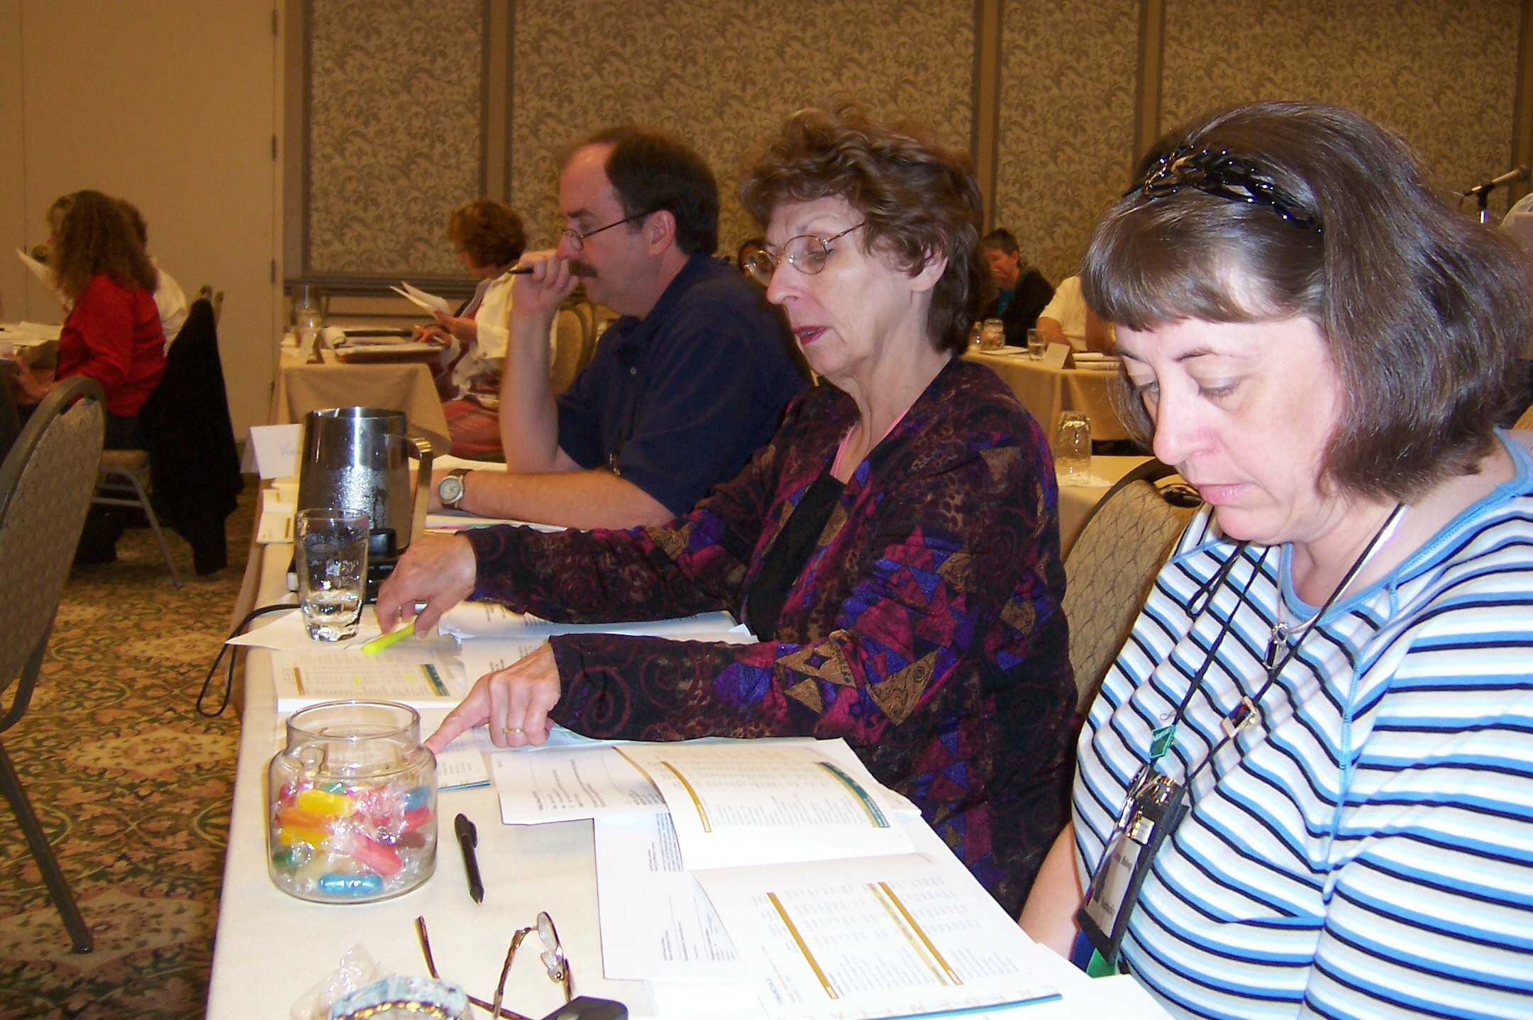

KSCPM Delegates at HOD
Dr. Kendra Stewart Speaks at Summer Luncheon
By Janice Earnest, CPM
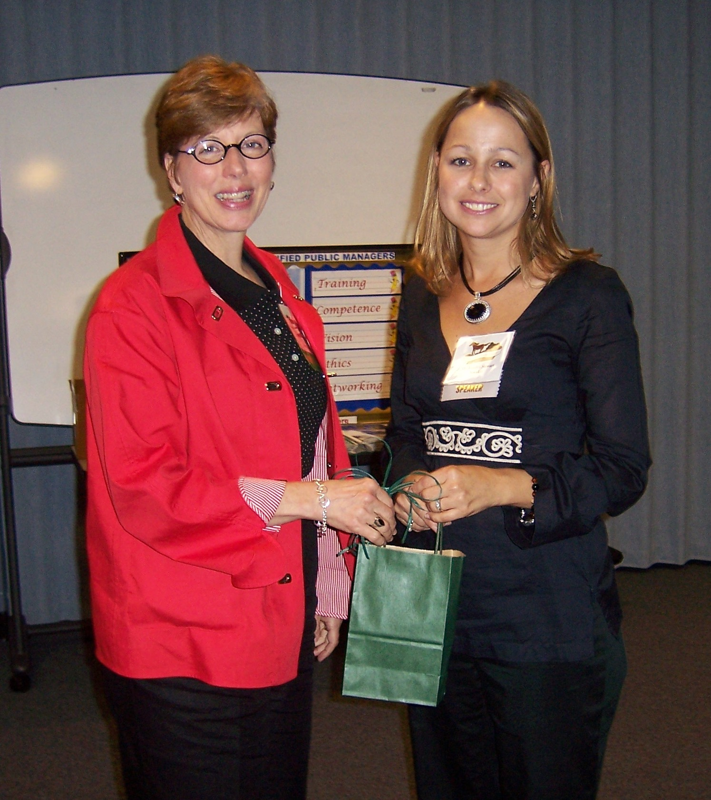
Katy Cave and Dr. Kendra Stewart

The Kentucky Society of Certified Public Managers® (KSCPM) held its summer speaker luncheon August 30 on the campus of Eastern Kentucky University in Richmond. KSCPM members at the Department of Criminal Justice Training were the hosts for this annual event.
Dr. Kendra Stewart, Assistant Professor, Department of Government at Eastern Kentucky University was the guest speaker. As you might imagine, with a title of “Cleavage and Corner Offices: Gender Dilemmas in the Workplace” it was a thought provoking topic. On the subject of salaries, Dr. Stewart said overall women earn 77% of what men earn and make 11% less than men in the same profession. Some of this inequity she attributes to the fact that women aren’t as likely to ask for a raise or negotiate for a higher starting salary.
Dr. Stewart concluded her presentation by showing a short comical video dealing with the subject of sexual harassment, and then answered questions from the audience.

After the drawing for door prizes of tote bags full of “goodies,” AACPM shirts, executive key chains, and pen and letter opener sets, the meeting was adjourned and attendees spent some time meeting people and talking to colleagues. The next speaker luncheon will be held in October in Frankfort. Watch for the e-mail announcement!

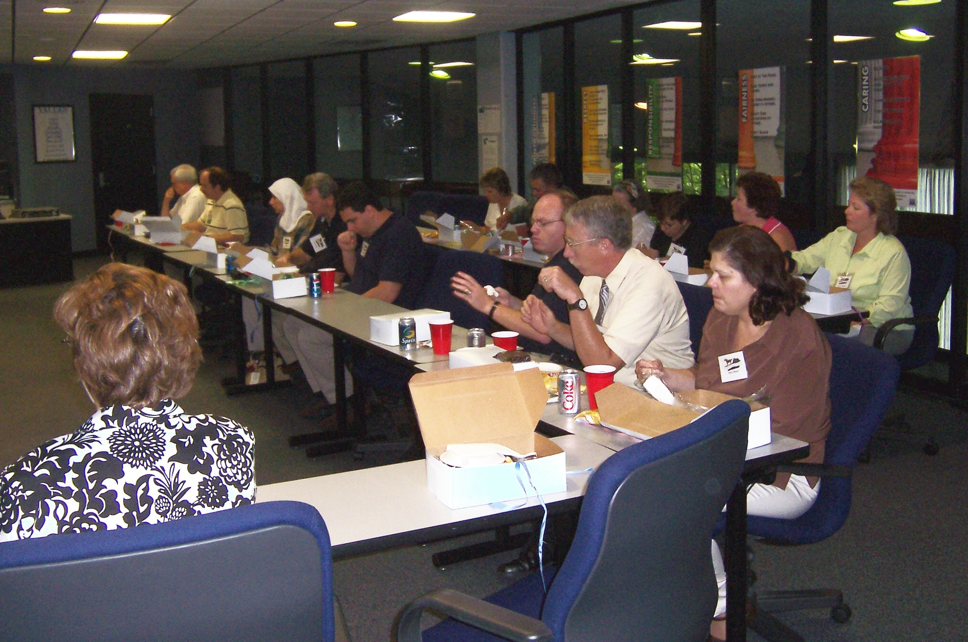
Luncheon attendees enjoy box lunches

Would You Like to Serve in 2008?

It’s time to begin thinking about running for a 2008 office with KSCPM. Ballots will be distributed prior to the December 4th Election/Awards Meeting. We will be electing the following officers: President-Elect, Secretary, and Treasurer. You must have completed the CPM program to be eligible for these offices and be a member in good standing with the Society.

There will also be openings on the Board of Directors. Our 2008 president, Tony Smith, would welcome volunteers to chair the various Committees.

If you would like more information about duties or requirements for any of these offices, please contact: Janice.Earnest@ky.gov.

Kentucky Society of Certified Public Managers®
Henning Nominee
James R. Brown

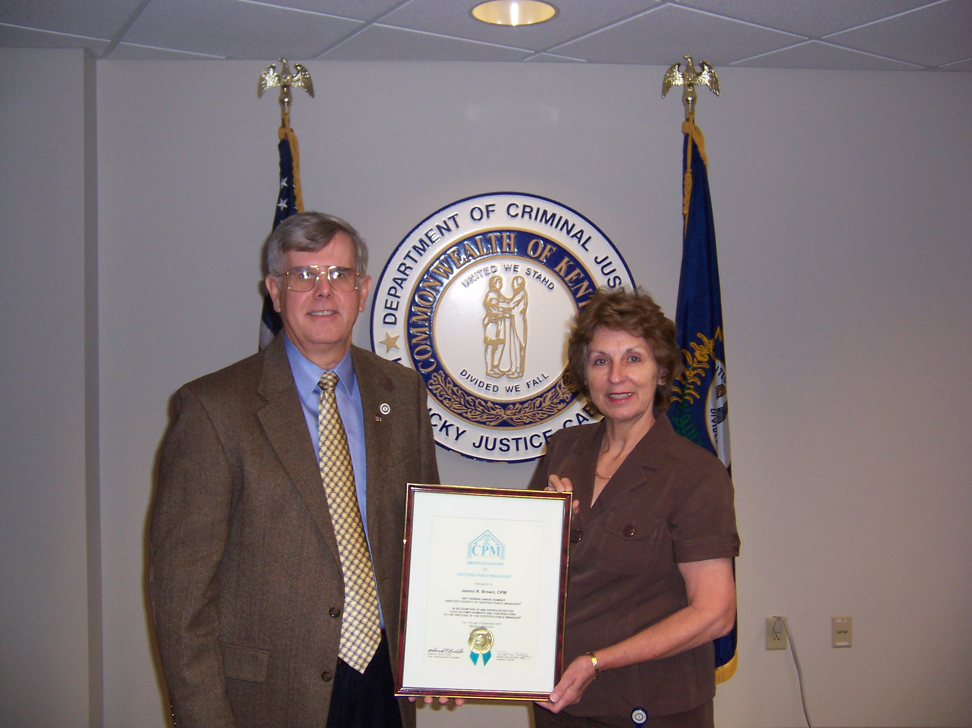

JR Brown receives AACPM Certificate of Recognition from Helen Koger

James R. (J R) Brown has devoted over 33 years of his life to public service in the criminal justice field. He served 20 years as a sworn police officer, retiring with the rank of Captain in 1994. At which time he started his second career as a police trainer and currently holds the position as the Branch Manager of the “” Leadership Institute. In each career, he has accepted leadership responsibility and earned appropriate promotions within those agencies.

Upon graduation from college in 1974, he joined the Madisonville Police Department. In 1977, he transferred to the Bowling Green Police Department where he could continue his education and completed a Masters Degree in Public Administration in 1980. While assigned to the patrol division, he received the “Governor’s Award for Outstanding Service in Crime Prevention” in 1979. In 1983, he was promoted to the rank of Sergeant and served as the shift commander over a year when the senior sergeant was off due to injury and the Captain was transferred to accreditation duties. In 1987, he was promoted to the rank of Captain and given the responsibility of a sector commander with additional duties to include preparing the patrol division’s budget, overseeing 24 school traffic officers and organizing special events. One of those special events was coordinating President Clinton’s visit for Congressman Natcher’s funeral in 1994.

On May 31, 1994, JR retired as a sworn officer to begin his second career with the Department of Criminal Justice Training as a ‘Law Enforcement Training Instructor’. He has served as a Basic Training Instructor, In-Service Training Instructor, Compliance Investigator, and Leadership Section Supervisor and now is the Branch Manager of the “” Leadership Institute.

JR served six years with the Army National Guard, receiving an honorable discharge in 1977. During that period he earned the rank of staff sergeant and served as the unit’s training N.C.O. In 1976, he received the “Outstanding Enlisted Guardsman of the Year” award for his unit.

Offices held, involvement and leadership in AACPM and KSCPM activities including committee assignments and year of service:
AACPM
2006 & 2007 – Member- Integrated Marketing & Resource Catalog Committee

Attended AACPM National Conferences:
- 2001 Scottsdale
- 2002 Atlantic City
- 2003 Charleston
- 2004 Topeka
- 2006 Louisville

KSCPM
- President – 2001
- President Elect – 2000
- Elections Chairman – 2003
- Co-Chair Site Selection Committee 2006 18th Annual AACPM Professional Development Conference
- Member – Host Committee 2006 18th Annual AACPM Professional Development Conference
- State Delegate to AACPM National Conference 2001, 2002, 2004.
- Chairman – Annual Training Conference 2000

In May of 2002, JR was assigned as the Supervisor of the newly created Leadership Training Section with the goal of producing a quality comprehensive leadership training program for law enforcement supervisors, mid-level managers and executives. In five years, our nominee has developed a vision into reality with the recent creation of the ‘Leadership Institute’ at the Department of Criminal Justice Training, Justice & Public Safety Cabinet. The ideas behind the “” Leadership Institute are comprised of a lifetime progression of learning, growing and advancement. The Institute serves over 800 state law enforcement leaders in its training programs each year.
The Institute creates a hierarchy of courses specifically designed for each step in a peace officer’s law enforcement career to assist in developing the leadership and supervisory skills necessary to be an effective community leader. The three corner stones of the Institute are: The Academy of Police Supervision (122 hours), The Criminal Justice Executive Development program (200 hours) and the School of Strategic Leadership (212 hours).

Kentucky is a recognized leader in its offerings for leadership training for its law enforcement supervisors, managers and executives. No other state in the nation offers a comprehensive leadership training program as does Kentucky. JR was a key person in the organization and development of the institute and its programs. The impact of the Institute’s training upon the future of our state is priceless!

When he enrolled in the CPM program he was the first in his organization to complete the program. Upon entry and graduation, he promoted the CPM program to employees within his agency. That organization, with a staff of 170, now has 58 CPM graduates and some 20 others currently enrolled in the program. He is proud to point out the CPM plaque that sets outside the commissioner’s office suite in the main lobby that lists all 58 graduate’s names. JR was his agency’s first member of the Kentucky Society of Certified Public Managers® (KSCPM) and he was able to recruit several members into the Society, some who become valued officers and committee members. JR received the society’s 2006 Gene Childress Leadership Award.

JR has consistently demonstrated the ability to organize and develop effective teams in all his ventures. During his tenure as Leadership Section Supervisor the section received his agency’s annual “Teamwork Award”. During his tenure as President of the KSCPM, he was able to effectively recruit and organize a leadership team that increased membership and activities for the organization.

He has consistently demonstrated the ability to look beyond today and envision the future as it could be. When he started the CPM program, he wondered why no one else from his agency has attended. Why couldn’t more attend and see the benefits? As stated before, almost 40% of his agency are now graduates or involved in the program. When he was given two instructors and told to create a leadership program, no one envisioned it would be a branch with two sections and some of the most creative leadership programs available.

Wilkinson Scholarship Recipient

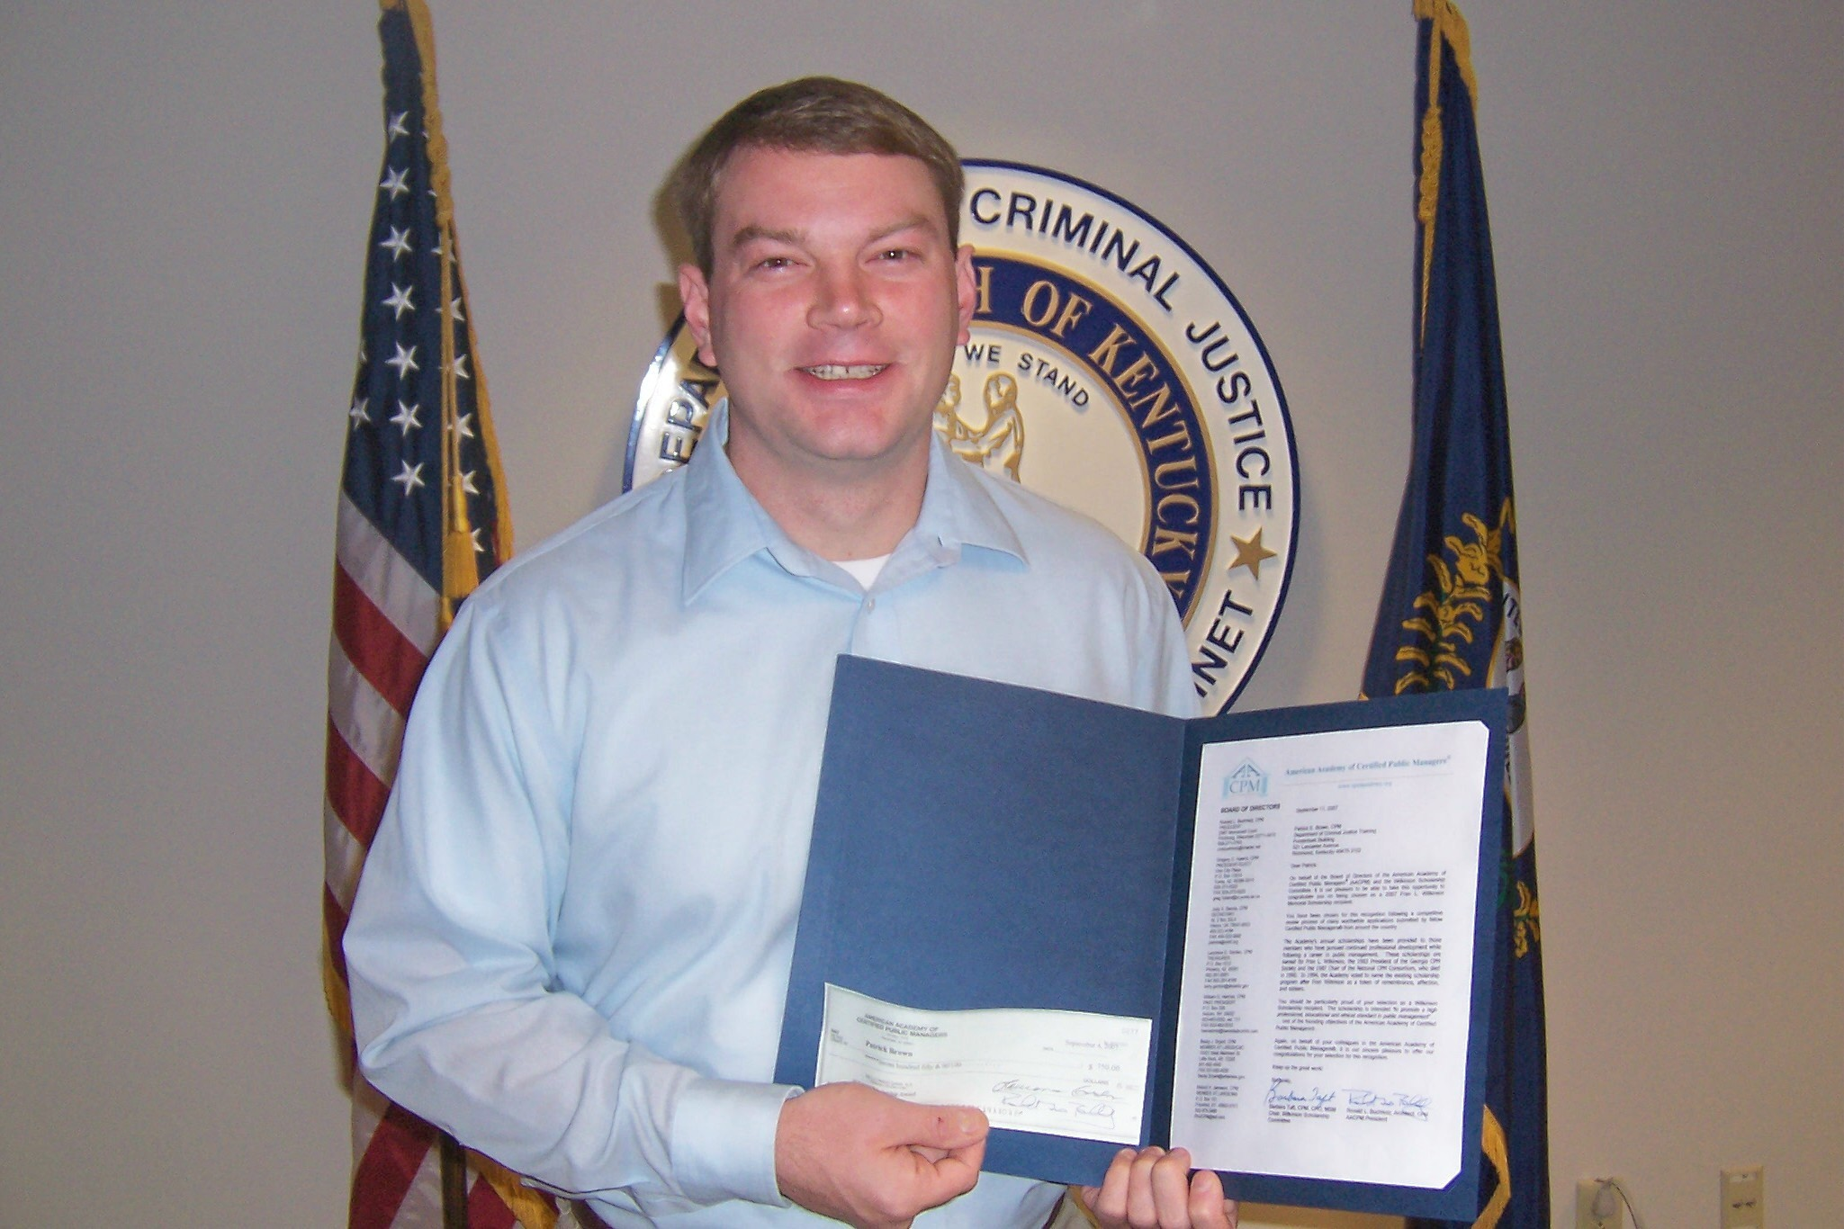

Patrick E. Brown, CMF
Department of Criminal Justice Training

The American Academy of Certified Public Managers® awarded two Wilkinson Scholarships at the 19th Annual Professional Development Conference held in September at Madison, Wisconsin. KSCPM member Patrick Brown was Kentucky’s first recipient.

The Fran Wilkinson Scholarship is awarded annually to those members who have pursued continued professional development while following a career in public management. It is intended “to promote a high professional, educational and ethical standard in public management…” one of the founding objectives of the American Academy of Certified Public Managers®

Patrick, who works in the Information Systems Branch at the Department of Criminal Justice Training in Richmond, is taking college courses at Kentucky State University to fulfill the requirements for becoming a Certified Public Manager. He has completed “Managing Human Resource Systems” and “Public Budgeting” and is enrolled in “Public Sector Management.”

When he completes the required courses for the CPM program, Patrick will have acquired 18 undergraduate hours toward the Bachelor of Public Administration degree at Kentucky State University or towards a Bachelor of Arts in Business Administration. “The money will be very helpful in paying for part of the cost of finishing the CPM program,” he said. “I feel honored to be chosen by the Academy as a recipient.”

Annual Awards

It’s time to start thinking about nominations for the Gene Childress Leadership Award and the Charlotte Glaser Award of Merit for 2007.

The Childress Award recognizes outstanding leadership in state government and we are looking for our fourth recipient this year. The Glaser Award recognizes an individual that has made outstanding contributions to the Kentucky Society. We are looking for our third recipient this year. Specific evaluation criteria are listed on each of the nomination forms.

Application forms can be found on pages 8 and 9 of this newsletter or the KSCPM website at:
http://www.kscpm.org/Nomn%20Form-Childress.pdf http://www.kscpm.org/Nomn%20Form-Glaser.pdf.

Nomination forms must be received or postmarked by Friday, November 2, 2007 to be considered. They can be emailed to larry.totten@ky.gov, faxed to 270-343-5510 or hard copies can be mailed to Larry Totten, PO Box 1021, Jamestown KY 42629.

Minutes of KSCPM Board Meeting
Tuesday March 27, 2007
GSC Room 536
11:30am – 1:00pm

CALL TO ORDER
The meeting was called to order by President Robinil H. Jameson. Those in attendance were: Robert Armstrong, Carmen Bishop, Katy Cave, Rebecca Conley, Brenda Crosman, Janice Earnest, Helen Koger, Jeanne Olivas, Tony B. Smith, and JoJuana Greene.

PRESENTATION OF MINUTES
The minutes of the January 23, 2007 Board Meeting were circulated by Helen Koger. Robinil called for the question. Katy Cave moved to accept the minutes as presented. Rebe Conley seconded. Motion carried.

TREASURER REPORT
Carmen Bishop stated the balance in our bank account is $7,122.95 plus $4,000 in two CDs. A motion was made to accept this report, seconded and the motion carried.

COMMITTEE REPORTS

- Elections Committee
No activity to report.

- Membership Committee
Membership Drive/Graduation
The Society currently has 95 paid members and 11 life members, for a total of 106. We will have 14 members graduating in April. Letters have been sent to these 14 members asking them to stop by the KSCPM booth and receive a token of our appreciation and participate in a group photo.

- Program Committee
Professional Seminar – Future Luncheons

Brenda Crosman presented information on food for the Professional Seminar, May 1. All the Way Shop, Family Affair and Personal Touch each gave bids. The Board discussed each and Carmen Bishop made a motion to choose Family Affair to provide food. Janice Earnest seconded. Motion passed.

Brenda also presented suggestions on items that could be purchased for “favors” for Seminar attendees. A green stoneware mug was considered. Board members will submit recommendations to President Jameson and a decision will be made soon.

Helen Koger reported that one state agency, Parks, has agreed to set up a booth at the Seminar. She asked for suggestions for possible other agencies. Treasurer’s Office, Deferred Compensation, Drivers’ Safety, KEEP, CHRIS. CCU, and Library and Archives were mentioned as agencies with booth possibilities. A contact person from each participating agency will be given a couple of minutes before the first break to tell about their booth and what they have to offer.

Janice Earnest has located four speakers. Door prizes are needed. Helen Koger will need six tables with one chair each for booths. One table will be needed for our KSCPM display and four tables for food. This is a total of 11 tables and 6 chairs.

- Finance Committee
2007 Proposed Budget
Robert Armstrong circulated a proposed budget, and Carmen assisted with details. The proposed amount of $1,000 was suggested in order to send a person to Madison, Wisconsin to the AACPM Conference, September 10-12. It was suggested to take into consideration all the costs associated with the luncheon, including gratuities and delivery charges when pricing the luncheon. Discussion followed. If we are profit based, then an increase is logical; if our mission is training for a non-profit organization, then maybe it is acceptable to absorb a small loss; however, if we continue to lose the amount of money that has been lost in the past, it will have a negative impact on our financial position. Further study may be necessary.

The President asked the Finance and Treasurer Committee Chairs to research the possibility of our non-profit organization achieving sales tax exempt status. This exemption could save a significant amount. The motion was made and seconded by Janice Earnest and JoJuana Green.

- Publications & Publicity Committee
Deadlines for newsletter committee reports/articles are listed on the 2007 calendar given to the board at the January meeting. President Robinil Jameson encouraged each officer or committee chair to submit an article for the quarterly newsletter.

- Awards Committee
Askew – Henning (Tony Smith will present Henning update)
Tony Smith reported that the 2006 Askew winner is Laura Lynn Best and she will receive an award at the CPM Graduation ceremony. Laura’s project was selected from the seven projects submitted by OEOD. Janice Earnest and Helen Koger will take photos as Tony is presenting the Askew award to Ms. Best.

President Jameson asked for nominations for the Henning Award. The chosen candidate will compete at the AACPM level and the nomination application must be postmarked no later than Friday, June 8, 2007. The Board chose a Kentucky Henning representative.

- GSC Update
Katy Cave reported that 208 people will graduate from the CPM Program. The graduation ceremony will be held at the Frankfort Civic Center on April 3, at 2 p.m. Plaques will be given to each graduate and photos will be taken by Cabinet. The Capstone projects were good and the sponsors were pleased. Katy may need help from the Society for greeting guests. A table will be available for the KSCPM display and membership information.

Jeanne Olivas reported that applications for the CPM Program will be accepted until May 31. Summer school for KY State University (KSU) CPM classes will start in June.
The CMF program through OEOD still exists. Some of the workshops in CMF provide the prerequisites for the CPM program. Participants who have completed the CMF do not have to repeat prerequisites in the CPM program. KSU provides 180 hours of the 330 hours needed to complete the program.

NEW BUSINESS

- 2007 AACPM Conference
The agenda for the AACPM Conference is on the AACPM web site. Tell President Jameson by late July if your agency will financially support you to attend.

Tony Smith recommended that we withdraw membership from the Coalition of State Employees. Carmen Bishop seconded and the motion carried.

ADJOURNMENT
The meeting was adjourned at 2 p.m.

Minutes submitted by Helen Koger, KSCPM Secretary.

Treasurer’s Report
Variance to Budget
September 18, 2007

Income:
Member Dues $2,945.00
Lunch Income 279.90
Product Income 20.00
KSCPM Seminar 4,600.00
Bank Interest 44.03
$7,888.93

Total Receipts $7.888.93

Expenses:
AACPM Dues $1,515.00
Lunch Expense 407.76
AACPM Delegate Exp 1286.94
Website 900.00
AACPM Assessment 100.00
Print & Postage 309.10
KSCPM Seminar 2,346.88
Misc. Exp 4,255.06

Total Expenses $11,120.74
Net Income (3,231.81)
Beginning Balance **10,897.68
Ending Balance $7,665.87

** CD’s - $2,000 @ 4.75%
$2,000 @ 5.20%

Gene W. Childress Leadership Award

Awarded for outstanding leadership in government

NOMINATION FORM

The nominee must be a full-time, permanent, public employee but does not have to be a Certified Public Manager®.

Nominee Information:

Name: _______________________________________________________________________
Title: _______________________________________________________________________
Cabinet/Agency: _______________________________________________________________________
Mailing Address: _______________________________________________________________________
Work Phone: ___________________________ Email: ___________________________________

POSSIBLE REASONS FOR NOMINATION:
- Exceptional level of service to the public
- Excellent role model
- Frequently performs above and beyond the call of duty
- Exhibits long term dedication to their organization

I am nominating this public employee for the Leadership Award for the following reasons: (Please be specific.)
________________________________________________________________________________________________________________________________________________________________________________________________________________________________________________________________________________________________________________________________________________________________________________________________________________________________________________________________________________________________________________________________________________________________________________________________________________________________________________________________________________________________________________________________________________________
If additional space is needed, please attach another sheet.
Nominator’s Information:

Name: _______________________________________________________________________
Title: _______________________________________________________________________
Cabinet/Agency: _______________________________________________________________________
Mailing Address: _______________________________________________________________________
Work Phone: _____________________________ Email: __________________________________

____________________________________________________ _______________________________
Signature of Nominator Date

Charlotte Glaser Award of Merit

Awarded for outstanding contribution to the Kentucky Society of Certified Public Managers®

NOMINATION FORM

The nominee must be a member in good standing of the Kentucky Society of Certified Public Managers®.

Nominee Information:

Name: _______________________________________________________________________
Title: _______________________________________________________________________
Cabinet/Agency: _______________________________________________________________________
Mailing Address: _______________________________________________________________________
Work Phone: _____________________________ Email: ___________________________________

POSSIBLE REASONS FOR NOMINATION:
- Exceptional level of service to the Kentucky Society of Certified Public Managers®
- Excellent CPM role model
- Promotes and supports Society functions
- Far exceeds expectations of a Society member
- Frequently performs above and beyond the call of duty
- Exhibits long term dedication to the Society

I am nominating this CPM for the Award of Merit for the following reasons: (Please be specific.)
________________________________________________________________________________________________________________________________________________________________________________________________________________________________________________________________________________________________________________________________________________________________________________________________________________________________________________________________________________________________________________________________________

If additional space is needed, please attach another sheet.
Nominator’s Information:

Name: _______________________________________________________________________
Title: _______________________________________________________________________
Cabinet/Agency: _______________________________________________________________________
Mailing Address: _______________________________________________________________________
Work Phone: _____________________________ Email: ___________________________________

____________________________________________________ _______________________________
Signature of Nominator Date

Kentucky Society Year 2007 Calendar – Dates to Remember

Fall Luncheon – October 22, 2007
Kentucky Transportation Building - C117, Frankfort, KY

KSCPM Annual Membership Meeting – December 4, 2007
Kentucky Higher Education Assistance Authority Bldg – Frankfort, KY

The mission of the Kentucky Society of Certified Public Managers is to establish, promote, enhance, and recognize the management profession through comprehensive training, networking, professional growth, and ethical standards of behavior; to promote service consistent with efficient and effective management practices; and to demonstrate vision and competence in professional management.

KSCPM 2007 BOARD OF DIRECTORS

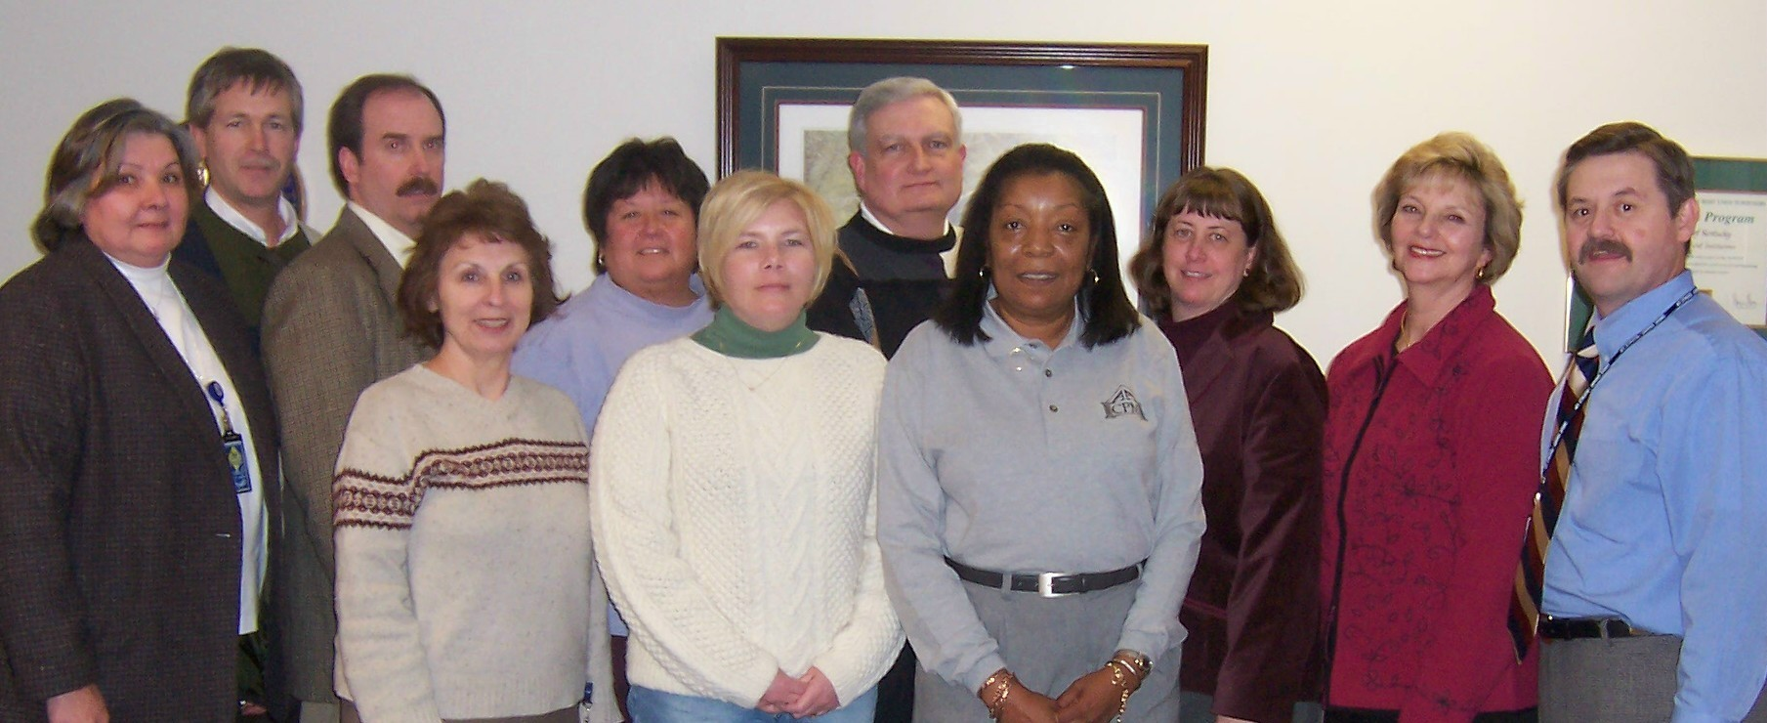
(L-R) Brenda Crosman, Robert Armstrong, Tony Smith, Helen Koger, Jeanne Olivas, Rebecca Conley, Larry Totten, Robinil Jameson, Carmen Bishop, Janice Earnest, Sherman Bowman (Absent from photo: Katy Cave, Pamla Wood.)

Robinil H. Jameson | President | RHJCPM@aol.com | 502-875-5466
Tony Smith | President-Elect | tonyb.smith@ky.gov | 502-564-3040
Helen Koger | Secretary | helen.koger@ky.gov | 859-622-3801
Carmen Bishop | Treasurer | carmen.bishop@ky.gov | 502-573-3390
Larry P. Totten | Immediate Past President | larry.totten@ky.gov | 270-343-2449
Jeanne Olivas | OEOD Liaison | jeanne.olivas@ky.gov | 502-564-8170
Janice Earnest | Election Committee | janice.earnest@ky.gov | 859-622-8062
Katy Cave | Program Committee | Katy.cave@ky.gov | 502-564-8170
 | Publications & Publicity Committee
Rebecca Conley | Membership Committee | rebecca.conley@ky.gov | 502-573-3390
Robert Armstrong | Finance Committee | robert.armstrong@ky.gov | 502-245-9091
Larry P. Totten | Awards Committee | larry.totten@ky.gov | 270-343-2449
Special Appointed Committees
Sherman Bowman | Legislative Committee | sherman.bowman@ky.gov | 502-564-7000  Ext. 4172
Janice Earnest | Historian & Archivist | janice.earnest@ky.gov | 859-622-8062
Janice Earnest  Robinil H. Jameson | Standard Operating Procedures | janice.earnest@ky.gov  RHJCPM@aol.com | 859-622-8062  502-875-5466
KSCPM | Web Page | http://www.KSCPM.org | POB 42  Frankfort, KY  40602-0042
AACPM | Web Page | http://www.cpmacademy.org

The Cutting Edge  KSCPM Newsletter  P. O. Box 42  Frankfort, KY 40602-0042 |  | POSTAGE
ADDRESS CORRECTION REQUESTED

