
www.KSCPM.org

April, 2008
Volume 8, Issue 1
Inside this Issue
1 | - KSCPM Professional  Development Seminar  - President's Podium
2 | - 2004 AACPM Henning  Winner Named Deputy  Commissioner
3 | - KSCPM Board Minutes  January 16, 2008
4 | - KSCPM Board Minutes  January 16, 2008 (continued)
5 | - Treasurer’s Report  - Test Your Knowledge
6 | - American Academy of  Certified Public  Managers® 20th Annual  Professional Development  Conference  - Recycle  - Newsletter Submissions  - Amazon.com  - Retiring in 2008?  - 2007 Photos
7 | - Dates to Remember
8 | - Registration Form for May  Professional  Development Seminar
9 | - 2008 Board of Directors

Kentucky Society
The Cutting Edge
Sharpening Your Management Skills through KSCPM

Certified Public Managers

KSCPM PROFESSIONAL DEVELOPMENT SEMINAR

“Making a Difference in a Changing Workforce”

Wednesday, May 14, 2008

THOMAS D. CLARK CENTER for KENTUCKY HISTORY

FRANKFORT, KY

President's Podium
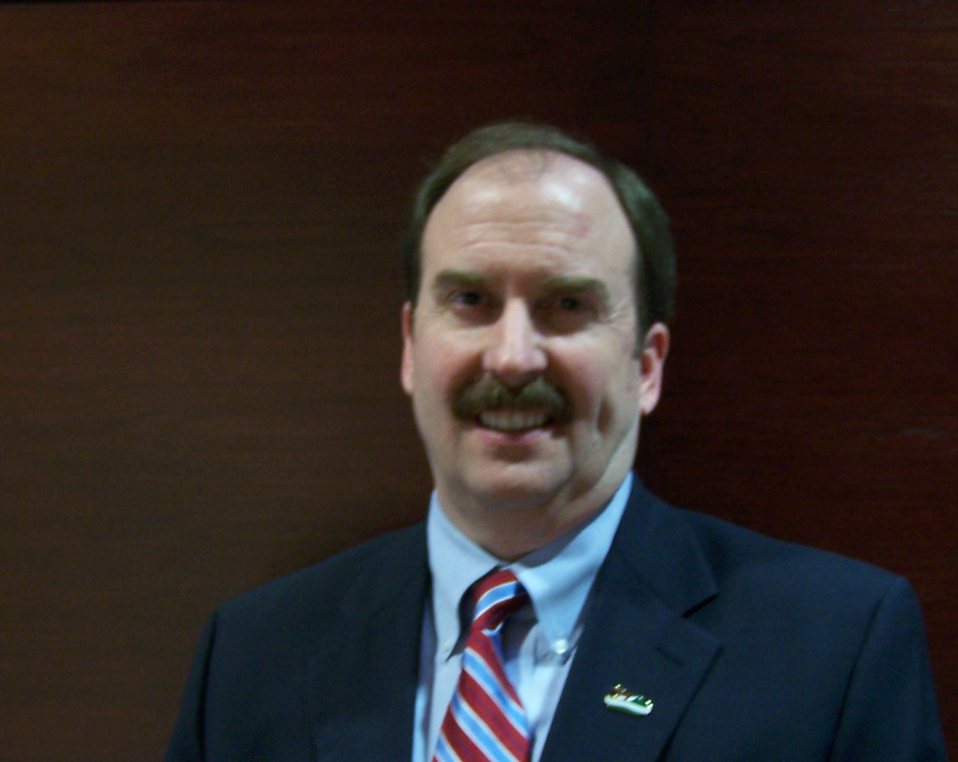

Changes and Challenges
In my first article for the year, I want to thank the membership and Board for the opportunity to serve again as your President. Also I want to thank Robinil for her leadership, not only as our 2007 President, but for the time she has served on the AACPM Board of Directors.
I titled this article Changes and Challenges. The changes include a new Governor with a new administration, just like our new KSCPM Board. Now that the Governor has taken office and the Legislature is here, we, as employees and managers, are constantly watching for changes that we know through our experience will happen, or we adapt to what eventually does happen.
Most of us will continue to do what we know how to do and that is to serve our customers and the people of the Commonwealth. We know that if the new administration changes priorities, we will respond to the new direction and continue to provide that service.
Now that the new Board has started, the Challenges are the goals we’ve set for this year. Again I believe this Board and our

membership will accomplish these goals through experience and innovation. These goals are:
- Maintain visibility in times of budget restrictions.
- Be an accepted management resource to Kentucky state government.
- Utilize the CPM program and KSCPM to improve state agencies.
- Expand KSCPM membership by offering quality opportunities for members to network, learn new management techniques, and refresh current skills.
We can accomplish these goals with the professionalism that we have in this organization. As Society members we embrace the challenge to help each other and our agencies through management and leadership skills that make us more valuable to the administration.
Over the years I’ve practiced Six Effective Leadership Behaviors that we learned in our CPM training. I plan to exhibit these this year as your 2008 President. These are
- Don’t dictate, facilitate. Work with people to provide support and direction.
- Be honest and ethical. Tell the truth. Share information. Keep your word.
- Let people do their jobs. Don’t do their jobs for them.
- Be positive. Don’t focus on what people are doing wrong. Focus on what they’re doing right.
- Use mistakes as opportunities to help make people better at what they do.
- Be inclusive in decision-making, as people are more likely to support a decision they’ve been a part of.
To new and long term members alike, I challenge you to get involved and continue to volunteer your leadership skills, time, and talents to move Kentucky forward.

Tony B. Smith, CPM
KSCPM President
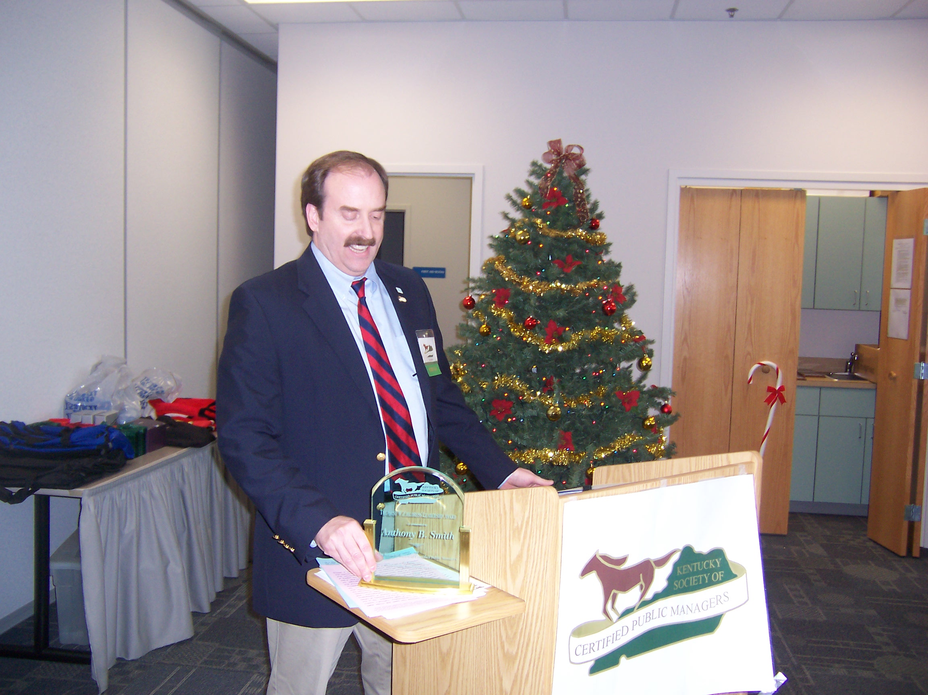

2004 AACPM Henning Winner Named Deputy Commissioner of Kentucky State Parks
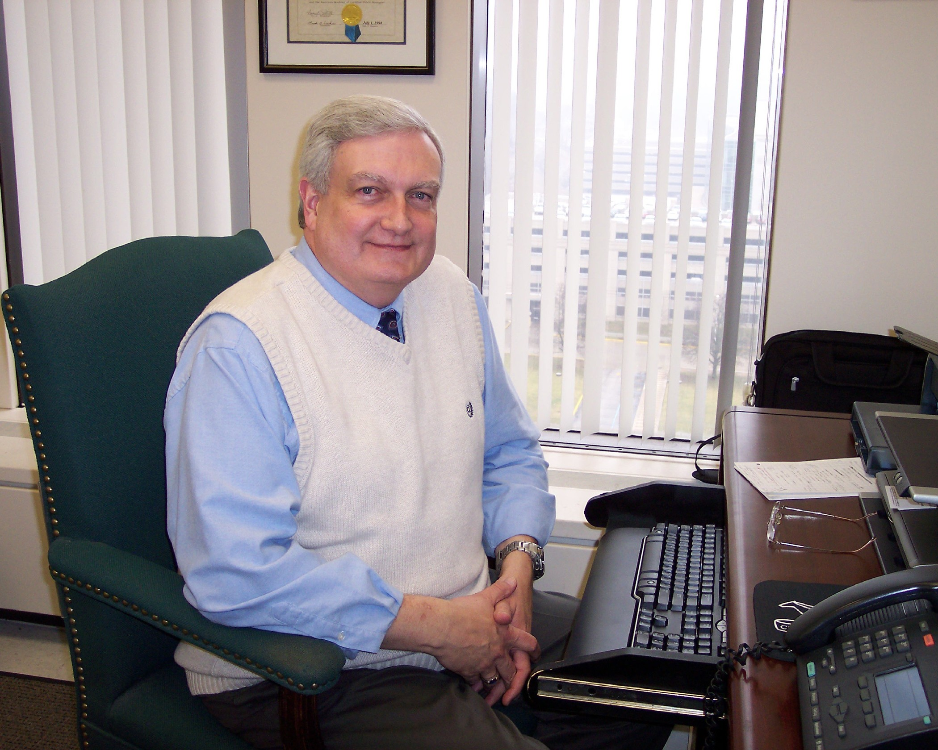

Long-time manager of Lake Cumberland State Resort Park, Larry Totten, has been named Deputy Commissioner of Kentucky State Parks. Larry earned his Certified Public Manager® certification in December 1993, the only person within his agency to have done so at the time. He currently holds the distinction of having the longest continuation of service on the AACPM Board of Directors. Larry has promoted the CPM certification to employees within his agency and several have successfully followed his lead. He continues to be an advocate for the program within his agency and was the Host Conference Chair of the 18th Annual AACPM Professional Development Conference.
His high level of active service to CPM organizations at both the state and national levels since his certification was earned include:
- AACPM President-Elect/President/Immediate Past-President: 2002/2003/2004
- AACPM Member-at-Large: 2001
- AACPM Treasurer: 1998, 1999, 2000
- KSCPM President-Elect/President/Past President: 1996/1997/1998/2005/2006/2007
During his seven years as a Member of the AACPM Board of Directors, Larry has served on and/or chaired almost every Committee within the Academy. While Treasurer, he published the AACPM Membership Directory for each of three years. As Member-at-Large in 2001, he updated the AACPM Standard Operating Procedures and issued updates in the following two years. He was a member of the Ohio CPM Program Initial Accreditation Team in 1999 and a member of the Wisconsin CPM Program Re-accreditation Team in 2003.
During his term as AACPM President, the Strategic Plan was completely updated, the Newsletter was revamped and renamed, and work began on updating the Academy website, including the issuance of the Academy’s Privacy Policy.
In a recent interview Larry said he is “excited about his new position and plans to share his experience for the betterment of the state park system”.

KSCPM Board Meeting
January 16, 2008
Transportation Building, Room 110

Tony Smith, President, called the meeting to order and congratulated Robinil Jameson and the 2007 KSCPM Board for a successful year.

Those in attendance: Robinil H. Jameson, Tony Smith, Helen Koger, Carmen Bishop, Jeanne Olivas, Janice Earnest, Katy Cave, Robert Armstrong, Sherman Bowman, Jennifer Woods and Ande Godsey.

President Smith has submitted the 2007 Annual Report to the AACPM National Committee and he also mentioned the successes of last year’s accomplishments.

President Smith then outlined his goals for the coming year as listed below.

2008 Goals: Maintaining visibility in times of budget restrictions;

- Planning and executing a Spring State KSCPM Seminar.

- Finalize the KSCPM Standard Operating Procedures Manual.

- Continue to expand the KSCPM membership by offering quality opportunities for members to network, learn new management techniques, and refresh current skills.

- To be an accepted management resource to Kentucky State Government, the KSCPM would hope to advertise the value of the CPM and the Society to agency heads for utilization of the Society as a valuable enhancement to their agencies.

- Pursue partnerships in conferences with other organizations with similar or related goals.

Presentation of Minutes: The December 2007 minutes were approved with one correction to the spelling of Laura Lynne Best’s name.

Treasurer’s Report: Carmen Bishop, Treasurer, reported that membership dues are behind, with only 24.9% paid dues as of January 2, 2008, and the current balance in our account is $6,631.49. The Board accepted the Treasurer’s report.

There are two CD’s due this year, and one comes due in March and the other in August. Carmen Bishop, Treasurer, explained the nine month CDs to the group and discussion on interest rates of a 9 month or 1-year CD occurred. The Board approved to continue renewing both CDs unless otherwise authorized

Committee Reports:

Election Committee: has had no activity since November.

Membership Committee: Robinil Jameson, Chair, suggested a logo magnet for $1.34 to be mailed with membership information. The board approved buying the magnets. Robinil also reminded the group that brochures needed to be ordered by mid to late March. She will send a reminder to people who have not paid their dues by mid-February.

Tony Smith reported of the 160 KCPM graduates in the Transportation Cabinet, only eight are KSCPM members. The Board discussed putting on an aggressive campaign to recruit new members.

The group discussed the current rules for membership in the KSCPM being based on the Certificate of Management Fundamentals, which is not required to enter the CPM program now. The Board thought all CPM members should be contacted after completion of the third on-line class by mailing them a brochure.

Program Committee: Jennifer Woods, Chair, had nothing to report, but would get with the History Center to finalize a date for the KSCPM Spring Seminar. Janice Earnest gave forms and information for planning the seminar to Jennifer and President Smith. President Smith would like to send an e-mail to all KCPM graduates about the seminar and the five hours of credit for attending. The Board wants to investigate getting the Governor’s office to send out the seminar information again this year.

Finance Committee: Bob Armstrong, Chair, reported expenses are $1000 less than income, and based on the budget we have the funds needed to operate for the year.

Awards Committee: Janice Earnest and Robinil Jameson will be working on changing the SOP for the Askew awards because of the changes in the GSC KCPM program. Robinil suggested we give 5 medallions, (one for each member of the group) since the projects are now group projects. Each medallion would cost about $65.00. The seminar profits could be used for the purchase

Legislative Update: Sherman Bowman, President-elect, reported that the key issues are retirement funding, expanded gambling, education, and bridges in Louisville. Sherman asked the group about hosting a reception for the legislature. Robinil explained because of the KSCPM non-profit tax status, 501C, it would be in violation of the tax status to be political. The board agreed that KSCPM role is to support the program and educate the legislators on the CPM program.

GSC Update: Jeanne Olivas, KCPM Program Manager, reported that GSC Ex. Director, Dr. Penny Armstrong, was leaving as of January 21 to become the Kentucky State University Assistant Provost for Outreach and Extended Programs.

The new Executive Director for GSC will be Sissy Meredith, PhD. Sissy comes from a strong educational background as a prior instructor of Public Speaking, Business Communication, and Industrial Communication at the University of Kentucky.

President Smith asked Jeanne for an updated GSC schedule to help with the different committees within the Society.

Announcements:
President Smith reminded committee chairs that they were to select their own committee members. This is a good opportunity to increase our membership or get new members active within the society.

Tony reminded everyone of the September 7-10 date for the AACPM Conference in Columbus, Ohio. He urged all of the board to make every effort to attend since it is within driving distance. One of the keynote speakers will be Tom Terez, business consultant and author of 22 Keys to Creating a Meaningful Workplace.

New Business:
The AACPM is now seeking candidates for 2009 officers for the positions of President-elect, Treasurer and Member-at-Large for Conferences and Committees. The deadline for applications is June 30, 2008.

Tony Smith has been appointed Co-Chair of the AACPM Ways and Means Committee. Congrats to Tony!

Janice Earnest requested that the Society purchase a green table cloth to go under our new logo table runner. Robinil said she would purchase a green table cloth.

Sherman Bowman made a motion for the Society to purchase a digital camera and photo card not to exceed $250.00. Robinil Jameson seconded the motion, the motion passed. Tony Smith will purchase the camera.

Carmen Bishop made a comment that if anyone knows of anyone that is interested in taking over the scrap booking duties, please let her know. It was suggested to put something in the next newsletter. She also reminded everyone to check on the web-site to make sure history and timeline are up-to-date.

Issues of Concern:
Governmental Services Center (GSC), the training institution for the Kentucky CPM Program, graduated 206 CPMs in 2007. We look forward to working with the new Governor’s administration in 2008 as the KCPM program moves forward with new applicants to build and maintain a core of skilled and knowledgeable leaders to direct, manage and supervise employees, programs, and projects in the public sector in Kentucky.

KSCPM is concerned about the affects of the statewide budget cuts on Governmental Services Center’s CPM program in attracting participants in the program and the Society. Also of concern is the budget and GSC’s activity on retaining existing members and agency support.

Robinil Jameson made a motion to conclude the meeting. Jeanne Olivas seconded the motion and the motion passed.


Treasurer’s Report
Variance to Budget
March 10, 2008

Income:
Member Dues $1,645.00
Lunch Income 20.00
Bank Interest 12.21
$1,677.21
Total Receipts $1,677.21

Expenses:
AACPM Dues $855.00
Lunch Expense 494.38
Website 225.00
AACPM Assessment 100.00
Awards & Honors 604.20
Print & Postage 43.24
KSCPM Seminar 200.00
Misc. Exp 208.19

Total Expenses $2,730.01
Net Income (1,052.80)
Beginning Balance **7,580.78
Ending Balance $6527.98

** CD’s - $2,071.05 @ 4.30%
$2,112.26 @ 5.20%

TEST YOUR KNOWLEDGE
Dust off your membership information, find your history, and dig out that brochure, because this newsletter contains a quiz! There will be a quiz in each of the remaining 2008 KSCPM The Cutting Edge newsletters. All of the answers can be found on the KSCPM website.

The rules are:
- The first three (3) correct answers e-mailed to RHJCPM@aol.com by April 10, 2008, 4:30 pm EDT wins the first prize (there will be (3) prizes per newsletter);
- the e-mail with the earliest time (computer time) wins; and
- one entry per person per quiz.

Good luck to all!

- What was the date of the Inaugural Membership Meeting of the KSCPM?

- Who was the 1st President of the KSCPM?

- At the 1996 AACPM Conference held in Louisville, Kentucky started a “new” tradition that has continued through all subsequent conferences, name the tradition.

- What year was the 1st KSCPM webpage developed?

- Name 2005 KSCPM Askew Award winner.

- Name 2 of the 4 Seminar speakers at the 2003 KSCPM Seminar.

- Name the 2004 AACPM Henning Winner

- Name the 2003 Gene Childress Leadership Award Recipient.

- Name the 2007 Charlotte Glaser Award of Merit Recipient.

- What are the yearly dues for active KSCPM members when they retire?

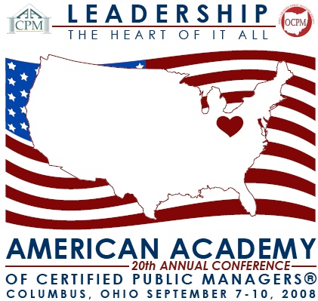

Recycle

If you enjoyed this newsletter, please share it with a CMF/CPM graduate you may know but who is not a KSCPM member - as part of our membership drive.

Newsletter Submissions

If you have an idea for a future newsletter article or would like to submit a book/training review, please contact Tony Smith. Final submissions for the next newsletter must be received no later than June 9, 2008.

Amazon.com

Why not help the American Academy of Certified Public Managers® when you shop? It's easy. All you have to do is enter the Amazon.com website through the Academy's website, www.cpmacademy.org. Then, for every purchase you make, the Academy earns a 5% bonus through Amazon's Associates Program.

Will you be retiring in 2008?
Be sure to complete the form on page 6 of the December, 2007 newsletter or go to:
http://www.kscpm.org/KSCPM_Retiree_Information.pdf

2007 in Review

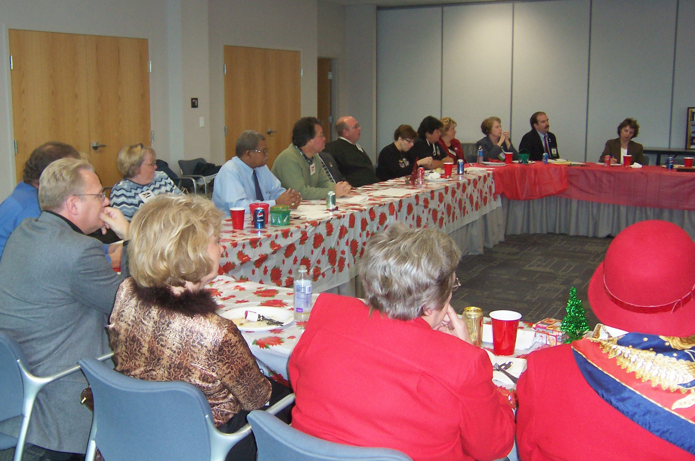

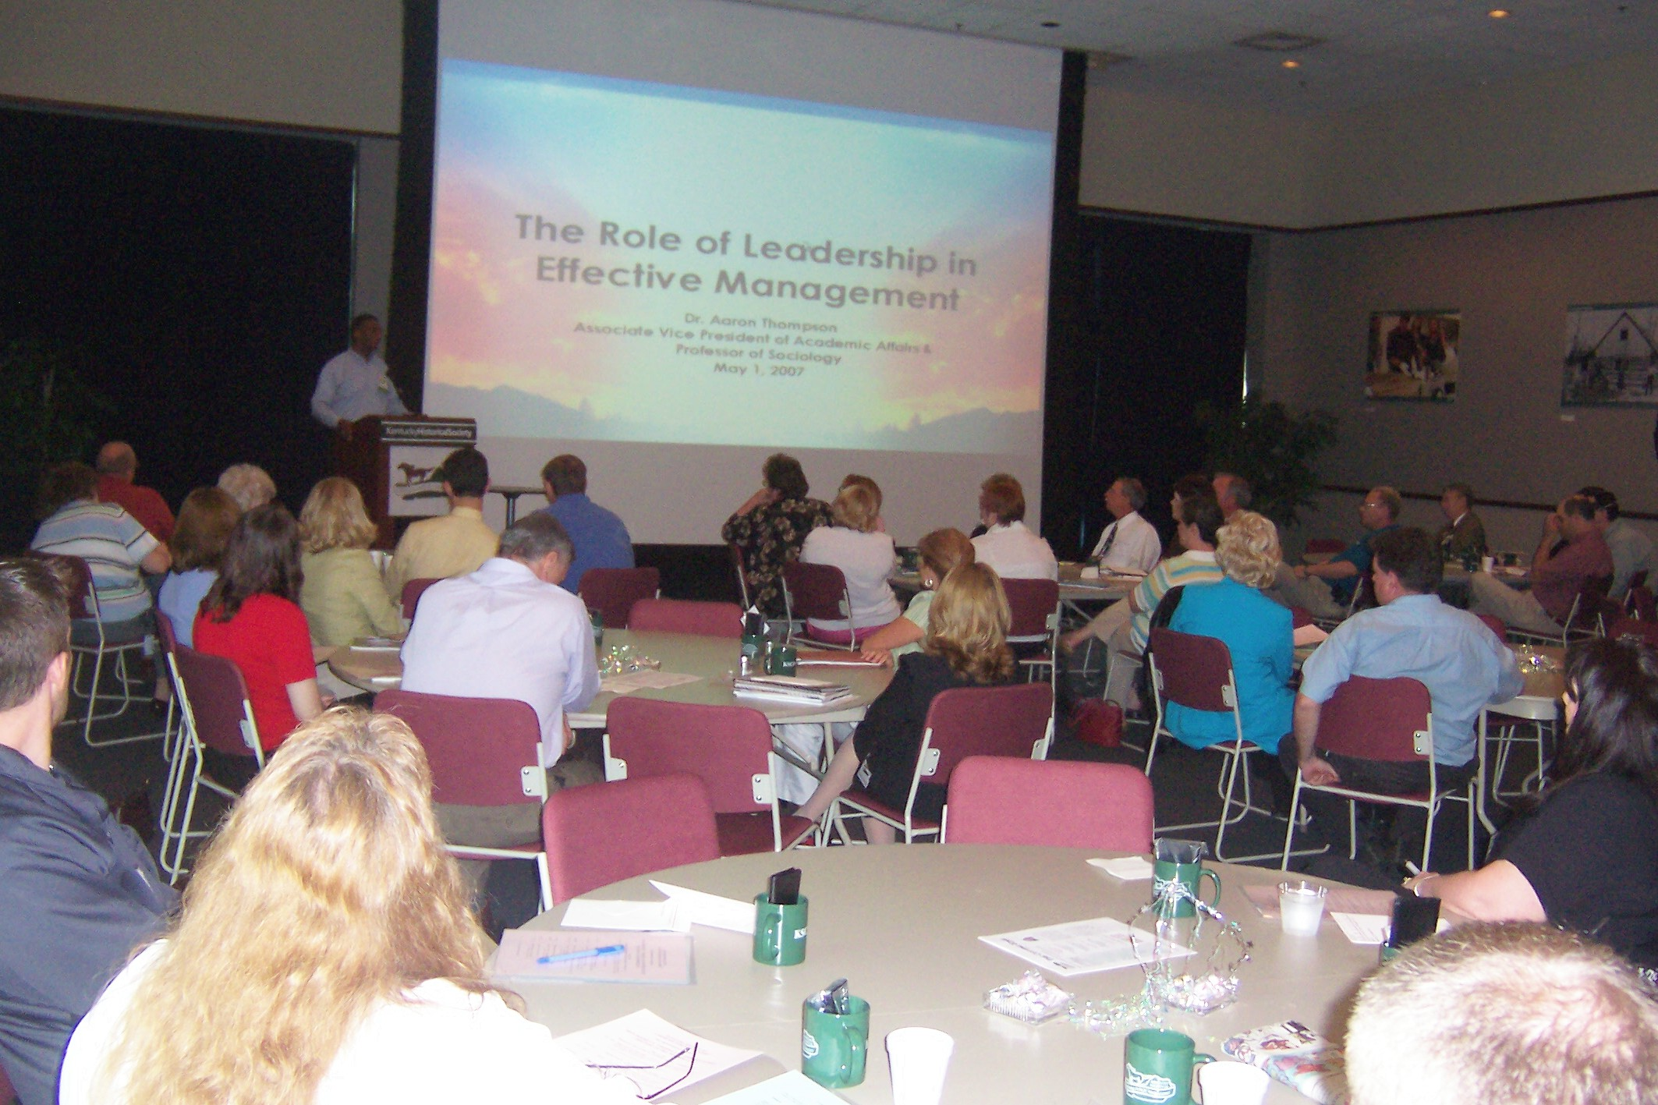

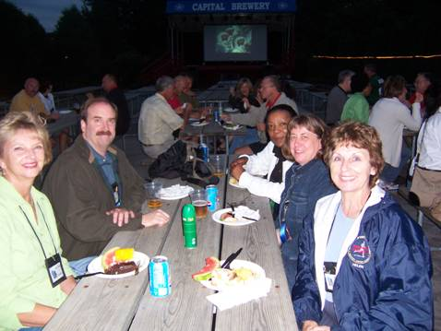

Kentucky Society Year 2008 Calendar – Dates to Remember

Annual Seminar – May 14, 2008,
Kentucky History Center, Frankfort, KY

Summer Luncheon – July, 10, 2008
Department of Criminal Justice Training, EKU, Richmond, KY

AACPM Professional Development Conference – September 7-10, 2008
Columbus, OH

Fall Luncheon – October, 2008
Date & Location TBA, Frankfort, KY

KSCPM Annual Membership Meeting – December 9, 2008
Kentucky Higher Education Assistance Authority Bldg – Frankfort, KY

The mission of the Kentucky Society of Certified Public Managers is to establish, promote, enhance, and recognize the management profession through comprehensive training, networking, professional growth, and ethical standards of behavior; to promote service consistent with efficient and effective management practices; and to demonstrate vision and competence in professional management.

2008 KSCPM PROFESSIONAL SEMINAR


May 14, 2008, Wednesday 8:30 a.m. - 4:00 p.m.

Thomas D. Clark Center for Kentucky History

100 W. Broadway, Frankfort, Kentucky

TOPIC: "Making a Difference in the Changing Workforce"

Registration Form:

Name__________________________________Title___________________________

Organization___________________________________________________________

Address______________________________________________________________

City_________________________State____________________Zip______________

Telephone______________________________Fax____________________________

E-mail________________________________________________________________

Registration Fee: $75 Members $100 Non-Members

- Registration Fee includes materials, breaks and luncheon.

Registration with payment or TP # must be received by Friday, May 2.
(KSCPM - Vendor # 58-1779206)

We cannot accept credit cards or inter-accounts.
- No refunds, but substitutions are permitted.
- Five hours CPE credit will be given for this seminar.

Mail Registrations with Payment to: | MESSENGER MAIL to:
KSCPM Professional Seminar  P. O. Box 42  Frankfort, Kentucky 40602-0042 | Carmen Bishop, Compliance Branch Manager  Office of Financial Institutions  1025 Capital Center Dr., Suite 200  Frankfort, KY 40601  Carmen.Bishop@ky.gov  (502) 573-3390, Ext. 284

KSCPM 2008 BOARD OF DIRECTORS
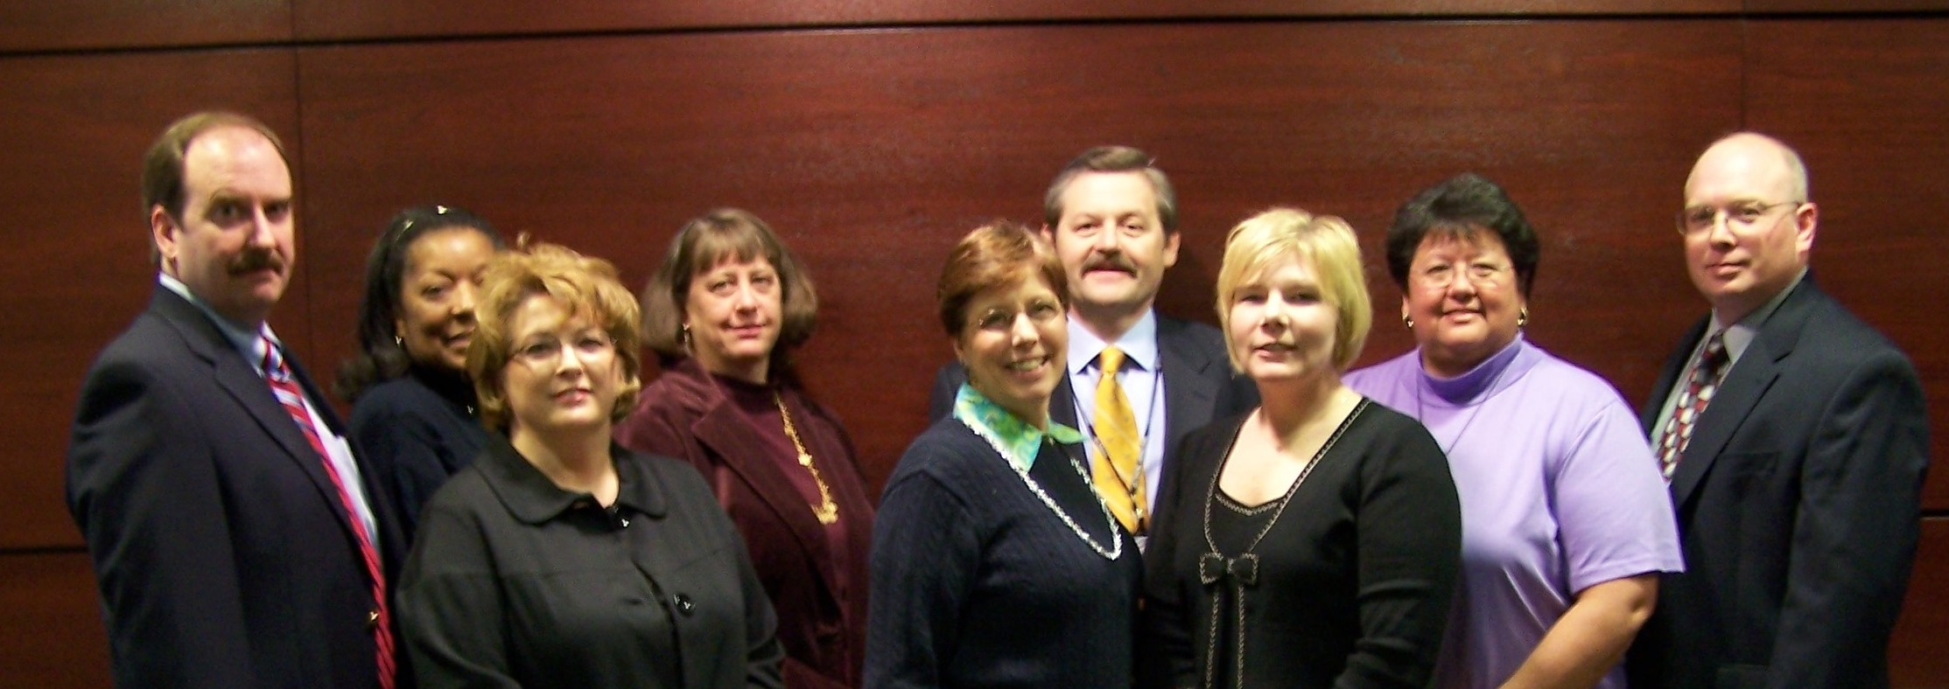

(L-R) Tony Smith, Robinil Jameson, Jennifer Woods, Carmen Bishop, Katy Cave, Sherman Bowman, Rebecca Conley, Jeanne Olivas, Ande Godsey, (Absent from photo: Larry Totten, Robert Armstrong, Janice Earnest)

Tony Smith | President | tonyb.smith@ky.gov | 502-564-9900  Ext. 3507
Sherman Bowman | President-Elect | sherman.bowman@ky.gov | 502-564-7000  Ext. 4172
Katy Cave | Secretary | katy.cave@ky.gov | 502-564-8170
Carmen Bishop | Treasurer | carmen.bishop@ky.gov | 502-573-3390
Robinil H. Jameson | Immediate Past President | RHJCPM@aol.com | 502-875-5466
Jeanne Olivas | OEOD Liaison | jeanne.olivas@ky.gov | 502-564-8170
Rebecca Conley | Election Committee | rebecca.conley@ky.gov | 502-573-3390
Jennifer L. Woods | Program Committee | jenniferl.woods@ky.gov | 502-210-5400
 | Publications & Publicity Committee
Larry Totten | Membership Committee | larry.totten@ky.gov | 502-564-8110
Robert Armstrong | Finance Committee | robert.armstrong@ky.gov | 502-245-9091
Robinil H. Jameson | Awards Committee | RHJCPM@aol.com | 502-875-5466
Special Appointed Committees
Sherman Bowman | Legislative Committee | sherman.bowman@ky.gov | 502-564-7000  Ext. 4172
Ande Godsey | Historian & Archivist | ande.godsey@ky.gov | 859-622-8052
Janice Earnest  Robinil H. Jameson | Standard Operating Procedures | janice.earnest@ky.gov  RHJCPM@aol.com | 859-622-8062  502-875-5466
KSCPM | Web Page | http://www.KSCPM.org | POB 42  Frankfort, KY  40602-0042
AACPM | Web Page | http://www.cpmacademy.org

The Cutting Edge  KSCPM Newsletter  P. O. Box 42  Frankfort, KY 40602-0042 |  | POSTAGE
ADDRESS CORRECTION REQUESTED

