
www.KSCPM.org

March, 2007
Volume 6, Issue 1
Inside this Issue
1 | - KSCPM Professional  Development Seminar  - President's Podium  - 2005 CPM Graduation
2 | - 2006 KSCPM Election  - 2007 KSCPM Election
3 | - 2006 Gene W. Childress  Leadership Award  - 2006 Charlotte Glaser  KSCPM Merit Award  - KSCPM Board Minutes  December 6, 2006
4 | - 2006 AACPM Conference  - KSCPM Member Portrait:  Taylor Carter
6 | - KSCPM Represents  Who You Are!  - Askew Award Winners  - Member Recognition  - 2006 AACPM  Henning Nominations  - Wilkinson Scholarships  - Recycle  - Newsletter Submissions  - Think Ahead
7 | - Newsletter Submissions  - Think Ahead  - American Academy of  Certified Public  Managers® 19th Annual  Professional Development  Conference
8 | - 2006 Financial Report
9 | - Dates to Remember
10 | - 2007 Board of Directors
11 | - Registration Form for May  Professional  Development Seminar

Kentucky Society
The Cutting Edge
Sharpening Your Management Skills through KSCPM

Certified Public Managers

KSCPM PROFESSIONAL DEVELOPMENT SEMINAR

“Management: Visions and Opportunities Shifting in the Workplace”

Tuesday, May 1, 2007

THOMAS D. CLARK CENTER for KENTUCKY HISTORY

FRANKFORT, KY

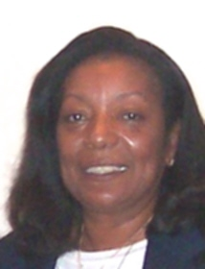

President's Podium

Hello, my Name is Robinil Jameson and I am proud to be the KSCPM President for 2007. We hope you will enjoy the return of “The Cutting Edge” newsletter. This edition will contain articles of interest from over the past two years. Please remember that proposed articles for the next newsletter must be submitted to Douglas Holt no later than June 8, 2007. Thank you.

2005 CPM Graduation

The Kentucky Certified Public Manager® Program graduated 35 managers on November 8, 2005. Officers and board members of the Kentucky Society of Certified Public Managers® assisted with the graduation by welcoming graduates and guests and escorting them to the photo session and reception following the ceremony. Five Society members were among the graduates.

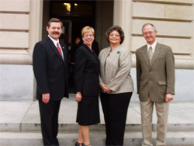
(L-R) Sherman Bowman, Katy Cave, Malea Vincent, Doug Price (Absent was Ruth Thompson)

We were privileged to have Bill Herman, AACPM President Elect representing the Academy, in attendance. Bill and 2006 Kentucky Society President Larry Totten spoke to the graduates about the program and encouraged them to become members of the Society.

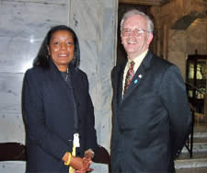
Academy officers Robinil .Jameson (2006 Kentucky Society President-Elect) and Bill Herman enjoyed the ceremony.

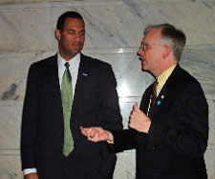
Bill Herman chats with Kentucky Personnel Cabinet Secretary Erwin Roberts.

Submitted by Janice Earnest.
2006 KSCPM Election

The KSCPM held its annual Election and Awards Luncheon on December 6, 2005. Following a delicious lunch of ham, turkey and all the trimmings, the members elected officers.

President-Elect Larry Totten assumed the office of President and served in 2006 with the following persons:

Robinil Jameson, President-Elect,
Carmen Bishop, Treasurer, and
Linda Renfro, Secretary.

During the Awards ceremony, Janice Earnest was honored as the recipient of the Charlotte Glaser KSCPM Merit Award. This award recognizes outstanding contributions to the Kentucky Society of Certified Public Managers®. Awards Chair Glenn Thomas read from the nomination:

“She has dedicated many hours and has served in several officer and committee positions. She is always positive, continuously promotes the CPM program and KSCPM, and frequently performs duties above and beyond the call of duty."

Janice attained CPM certification in November of 2000. She became a member of the Society in 2001 and served as Historian/Archivist last year. She also helped compile a Standard Operating Procedures Manual for the Society and was a member of the Registration Committee for the 2006 AACPM Professional Development Conference.

The 2005 event concluded with a drawing for several door prizes. Afterwards, newly elected officers, Board members and the 2006 Conference Committee gathered for a short meeting, as they were working on plans for the AACPM Conference to be held in Kentucky last September.

Submitted by Janice Earnest.

2007 KSCPM Election

The election for 2007 KSCPM officers was conducted in December, 2006. Official embossed and numbered ballots were distributed to members with instructions to cast their vote in person at the Annual Election/Awards Luncheon in Frankfort, or by mail.

Of the 117 ballots mailed out, 61 were returned, electing the following officers to serve with President Robinil Jameson in 2007:

Tony Smith - President-Elect,
Helen Koger – Secretary, and
Carmen Bishop – Treasurer.

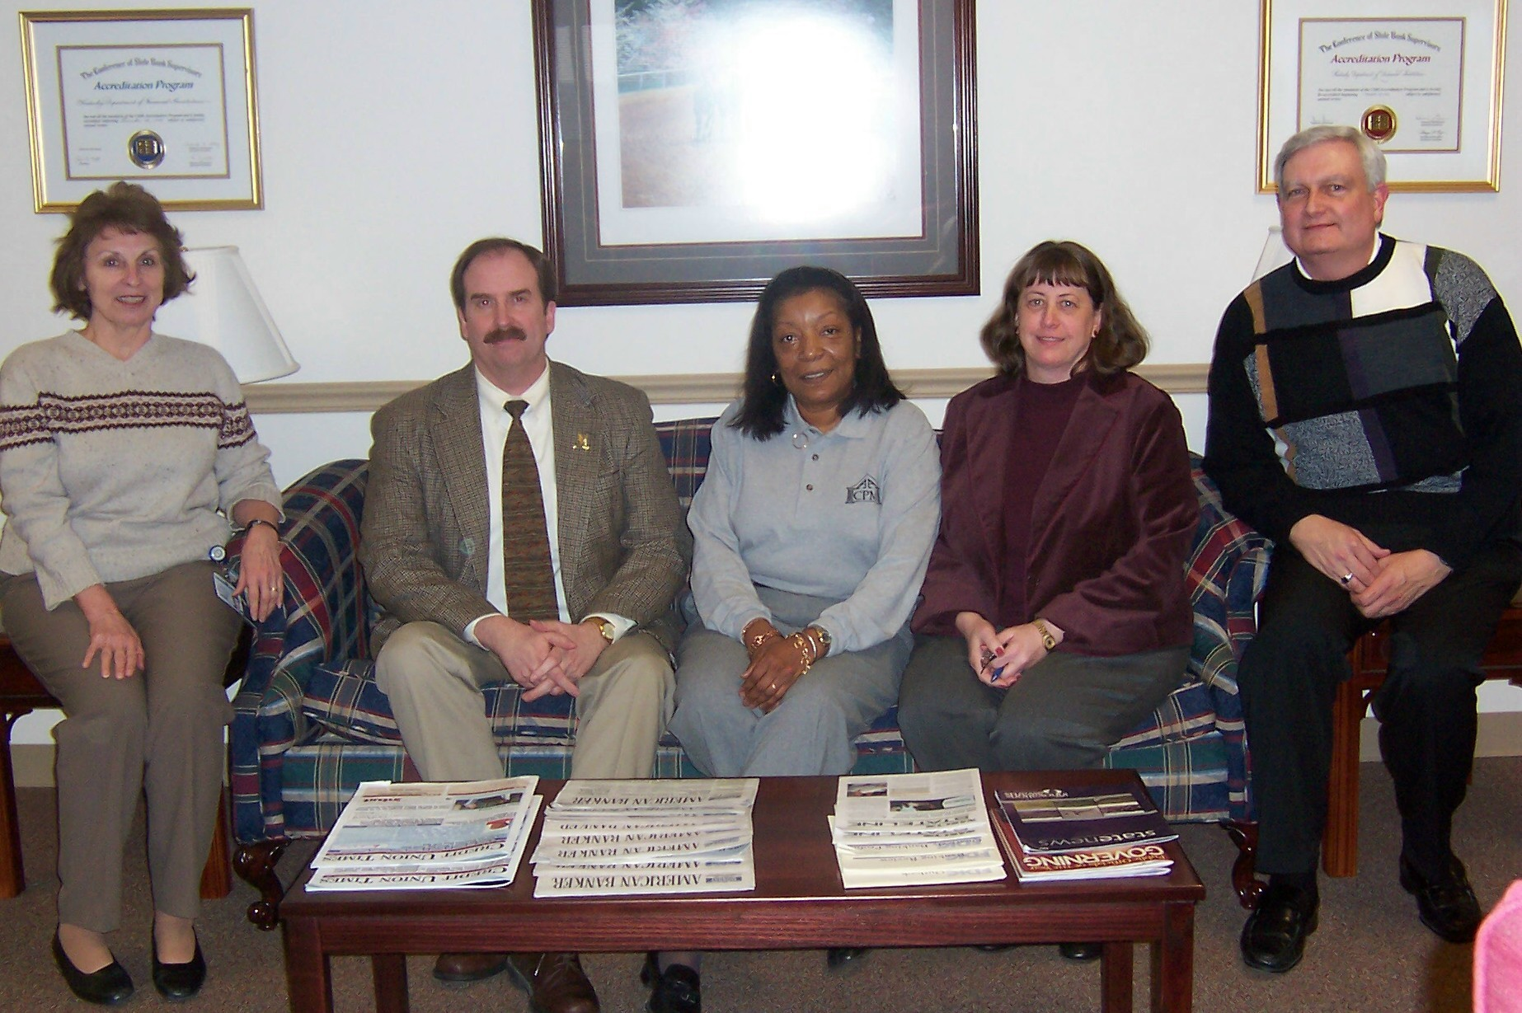
(L-R) Helen Koger, Tony Smith, Robinil Jameson, Carmen Bishop, Larry Totten - Past President.

It’s not too early to start thinking of an office you might aspire to for 2008, or of someone that would make a good officer that you might encourage to run.

Submitted by Janice Earnest.

2006 Gene W. Childress
Leadership Award

The 2006 Gene W. Childress Leadership Award was presented to J. R. Brown, Branch Manager, Leadership Institute Branch, Department of Criminal Justice Training. The award is given to an individual who exhibits outstanding leadership in government. Mr. Brown has served in law enforcement and currently is responsible for leadership training for law enforcement personnel across the state.

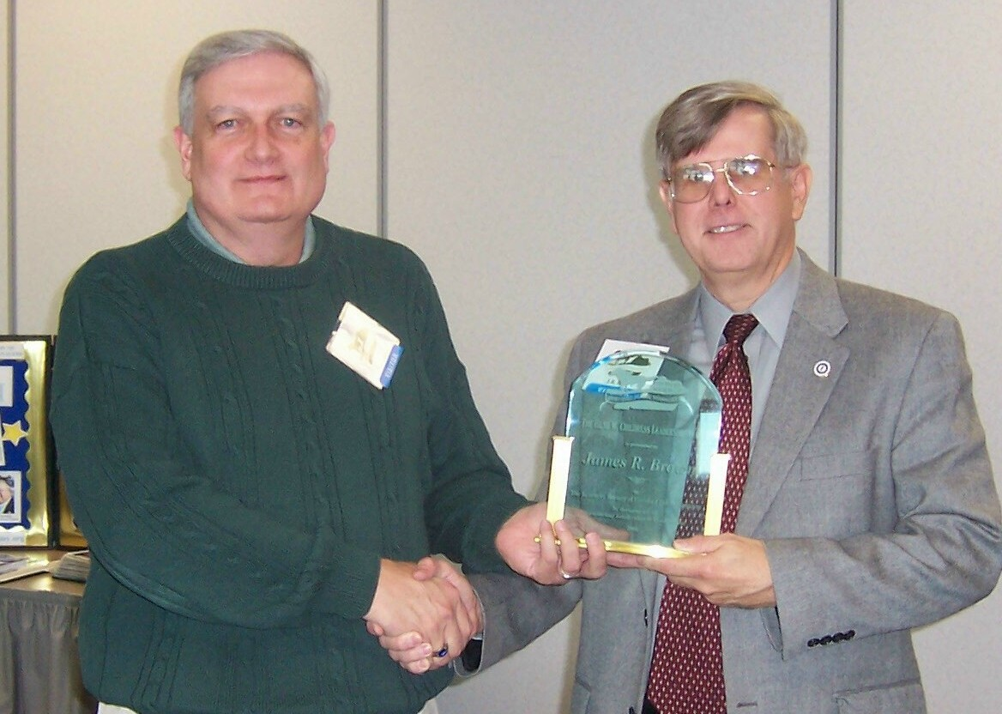
Larry Totten, 2006 President, presenting the Award to J.R. Brown.

J.R. has served as a role model for many in his agency and in the KSCPM. He was the first CPM graduate from his agency and served as KSCPM president in 1999. Membership increased significantly during his term. He served as a Delegate to AACPM Conferences and is directly responsible for several persons enrolling in the CPM program and/or becoming officers or board members in KSCPM. He is a leader who exhibits an exceptional level of service and long-term dedication to government.

2006 Charlotte Glaser
KSCPM Merit Award

The 2006 Charlotte Glaser KSCPM Merit Award was presented to Larry Totten for his dedication to the certified public manager program at the state and national level.

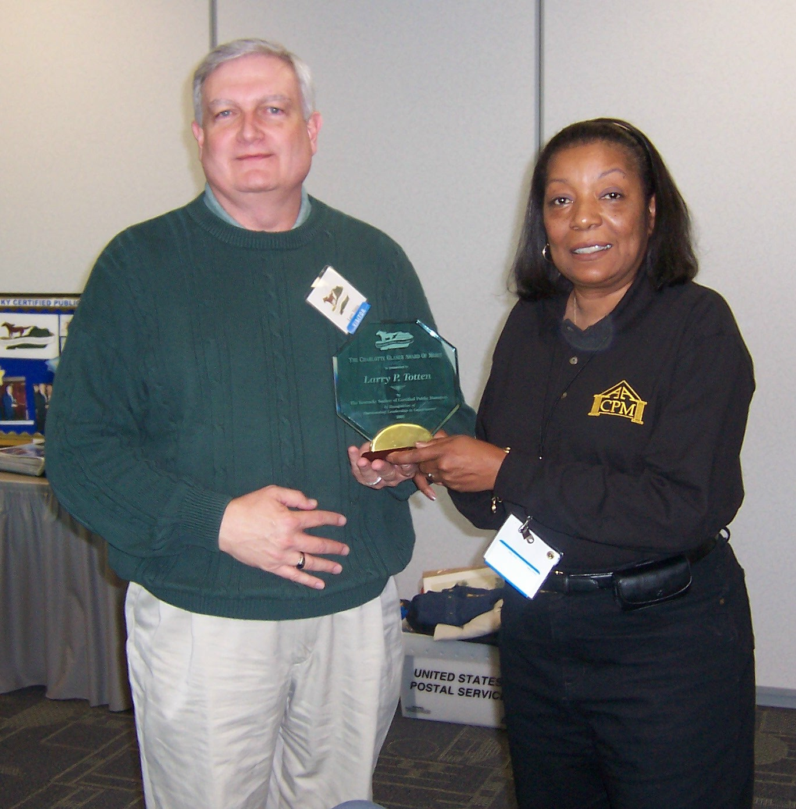
Robinil Jameson, 2007 President, presenting the Award to Larry Totten, 2006 President.

Larry Totten’s nomination states that he exhibits the highest level of dedication and service to his agency and its customers, working continuously to improve operations and delivery of services. This professionalism is also manifested in the high level of active service to CPM organizations at national level and by extension the Society level since his certification was earned in December 1993. He currently holds the distinction of having the longest continuation of service on the AACPM Board of Directors. Larry Totten has promoted the CPM certification to employees within his agency and several have successfully followed his lead. He continues to be an advocate for the program within his agency by his membership in his local Society and the AACPM.

KSCPM Board Minutes
December 6, 2006

Officers and Committee Chairs in Attendance: Larry Totten, Janice Earnest, Rebecca Conley, Robinil Jameson, Carmen Bishop, Tony Smith, Linda Renfro, Sherman Bowman, Mary Morris, Jeanne Olivas, and Helen Koger

Since this was the December, 2006 luncheon, numerous certified public managers, society members and guests were present.

A copy of the Treasurer’s report on the AACPM Conference account and KSCPM checking account was distributed. Larry Totten reviewed the AACPM conference account and noted that the KSCPM received $3,755.44 from the proceeds of the conference.

Ballots were cast and counted for officers for the upcoming year. Tony Smith was elected as President-Elect, Helen Koger as Secretary and Carmen Bishop as Treasurer.

Larry Totten thanked everyone who worked at the AACPM conference and presented gifts of appreciation to those who helped. Robinil Jameson presented outgoing President Larry Totten with a plaque in appreciation for his work in the position. Future AACPM Conferences will be held in the following states: Madison, Wisconsin; Columbus, OH; Florida; Oklahoma and Utah.

The Gene W. Childress Leadership Award was presented to J. R. Brown, Branch Manager, Leadership Institute Branch, Department of Criminal Justice Training. The award is given to an individual who exhibits outstanding leadership in government. Mr. Brown has served in law enforcement and currently is responsible for leadership training for law enforcement personnel across the state.

The Charlotte Glaser KSCPM Merit Award was presented to Larry Totten for his dedication to the certified public manager program at the state and national level.

Jeanne Olivas announced the next CPM graduation will be held on April 3, 2007.

Robinil Jameson said the professional seminar will be moved from the fall to spring due to the annual conference being held in the fall.

Katy Cave will chair the Program Committee next year. Please let her know if you have any ideas for guest speakers.

Douglas Holt will be the newsletter editor.

Pamla Wood will continue to spotlight CPMs in the newsletter and would appreciate any ideas on people to write about.

Tony Smith stated he looks forward to serving as KSCPM president-elect next year. He plans to have Kentucky continue to maintain a strong presence at the national level.

Submitted by Linda Renfro.

2006 AACPM Conference

In September 2006, the Kentucky Society hosted the 18th Annual Professional Development Conference of the American Academy of Certified Public Managers in Louisville at the Galt House. This event marked the 10-year anniversary from the last time that Kentucky was host. It was also the 30th anniversary of the establishment of the Certified Public Manager program.

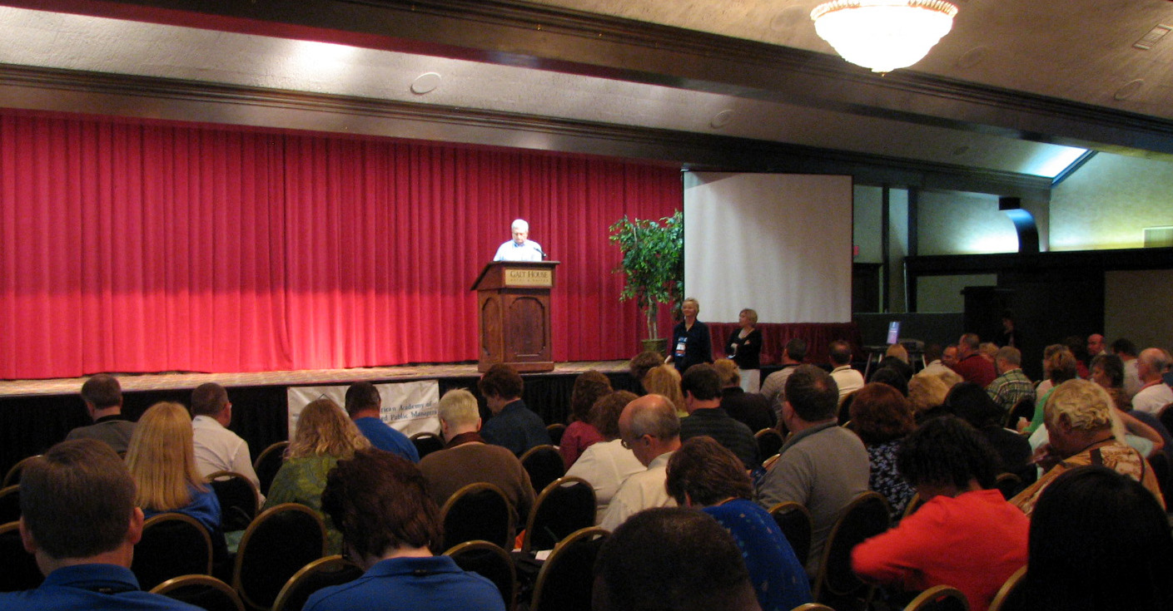
View from the audience.

The theme for the Conference was “The New Realities – a Decade Later”, carrying forward the theme from the ’96 event.

For participant reflections on the event, see the associated article in the AACPM online newsletter at: http://www.cpmacademy.org/newsletter/dec_06/reflections.html

View the related PowerPoint presentation at:
http://www.cpmacademy.org/default.htm

Belle of Louisville excursion.

KSCPM Member Portrait

Getting Oriented to Jump Barriers: An interview with Taylor Carter, Vocational Rehabilitation Specialist.

As an Employment Relations Specialist in Education’s Office of Vocational Rehabilitation, it is CPM Taylor Carter’s job to help people get jobs. On the employer end of his work, he resembles an ambassador: from his program to the Chamber of Commerce. He assists businesses to hire and retain skilled workforce, matching job requirements with applicant skills and helping those businesses reduce the costs of recruiting, training, and assessing new employees.

His true consumers, however, are not the employers. What Taylor Carter does is help people break through barriers, and his consumers have more than their fair share. By the time a man or woman shows up in a session with Taylor, a co-worker in Vocational Rehab has verified that he or she has some kind of disability and at least one employment issue, related to that disability, which interferes with employment. The disability can be physical or emotional. The issue might make it hard for the consumer to get a job, or it might make it tough to keep a job. Before Taylor meets the consumer, a Vocational Rehab counselor has also assessed the nature of the person’s issue and what is needed to overcome it, and the counselor and the consumer have established an employment plan.

It is at that point that Taylor begins to do what he can to help. If the person is job-ready, Taylor is likely to make a direct placement. If the person is not job-ready, Taylor’s mission is to prepare him or her to be employable – and employed.
One option is to enroll the consumer in one of Taylor’s one-week, job orientation workshops. Taylor runs these workshops, which are packed with useful information and coaching. Workshops cover ADA & disability laws, issues and challenges. The program identifies personality skills and transferable skills. During the workshop, consumers set career and financial goals, clarify jobs and careers that interest them, and consider what type of work and social environments they prefer. Participants learn about the stages of employer job searches and how to plan, organize, and conduct a traditional job search as well as use networking to explore the job market. Consumers learn how to fill out applications, assemble resumes, write cover letters, and send thank you letters. They practice interviewing. Taylor encourages participants to think like an employer, to examine and anticipate employer expectations. Through this process, graduates learn to build a networking system, develop communication skills, and become familiar with paper work. Most gain self-esteem, motivation, and positive thinking.

Taylor said his CPM training (in the 90’s) helped him better anticipate how another person might react, and deduce their needs. This has aided him in understanding the needs of employers, while also giving him the skills to interact more productively with the various personalities of co-workers. The training has been especially useful in conflict resolution, which he pointed out is necessary in every aspect of a person’s life. He expressed pride in having achieved his CPM. “The material and instructors were great,” he said, and the “sharing of problems across state government was enlightening.”

From my conversation with Taylor, I sensed the compassion he brings to his work. However, he made it clear that he doesn’t “sugarcoat.” He confirms to his workshop audience that life isn’t fair. He sees a lot of negativity and anger. Yet through it all, Taylor’s passion for his work is also evident.

“It comes from the heart,” Taylor said, “but I know I can’t make them change, and I try not to take it too personal when I’m in there with people who don’t want to be motivated.” One message he gives a lot is, “If you think you can do something, you probably can, and if you think you can’t, you probably can’t.” He talks common sense, sometimes telling his consumers that he hasn’t yet “found a manual that shows how you could be without a job and still have a cell phone, a house,” much less an I-Pod!

Taylor has a business relationship with employers; it is not about disabilities, but about people who can do the job. He said his research on employer needs has revealed that the first thing they want is someone who will show up. They want people who get along with people and have a positive attitude. The businesses know that they can train people, but they can’t change attitudes. His ability to rapidly respond to employer needs, including those in several cabinets, is much welcomed. Some of the extra assistance he provides to employers is to visit the site and make accommodations recommendations; he is also available to mediate, if needed, if disputes arise between employees and employers: a common practice among job placement practitioners. He also addresses groups of employees who are about to be “downsized” or “retrained,” giving them encouragement based on knowledge of the market and tips for job-seeking.

It was clear to me that once a consumer has been touched with Taylor’s training, placement, or advice, that person has a lot going for him or her. Yet Taylor wisely recognizes the difference between performing well in a classroom environment, learning new concepts and practices, and applying those new tools. He said the four projects he completed during his CPM training were instrumental in assimilating classroom training, but also said he’s seen too many people “keep doing things the same way as before, not changing their habits.” In this way, his consumers with disabilities and each CPM graduate have the same barriers to break through: the human and management challenge to change, to grow.

Submitted by Pamla Wood.

KSCPM Represents
Who You Are!

You're definitely not alone!

That's a key message that we would like to send to other CPMs. And there is nothing more critical to the KSCPM’s survival than steady, solid membership growth.
Members benefit from mentoring and getting honest, candid feedback from people who share the same interests. You get to share real experiences with each other and learn from one another. Our relationship with the American Academy of Certified Public Managers® and other societies open opportunities for you to gain and hone your leadership skills.

We hope you will decide to become a member and add your name to those of your colleagues who have already demonstrated their commitment to our profession through membership. If you would like additional information or have any questions about a particular area of activity, please let us know.

Visit our website at http://www.kscpm.org or contact Rebecca Conley at: Rebecca.conley@ky.gov.

Askew Award Winners

The 2005 Kentucky Askew Award Winner was Shawn Marie Herron, Department of Criminal Justice Training, for “Consular Notification Requirements for Kentucky Law Enforcement Agencies.”

The 2006 Kentucky Askew Award Winner was Charlotte Faeth, Transportation Cabinet - District 7, for "Replacing a Retiring Employee's Position with Another Position.”

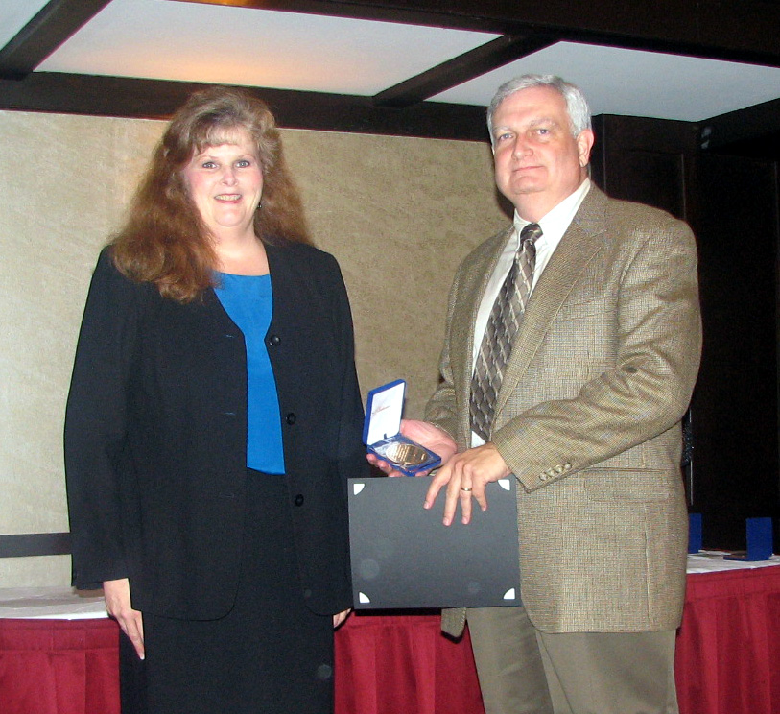
Larry Totten receives Askew Award on behalf of Kentucky Recipient from Wilkinson Chair Paula Green.

Member Recognition

If you know of a KSCPM member that has received an honor or a new position, please let us know.

2006 AACPM
Henning Nominations

The Henning Award is presented annually to an Active Fellow who, through their efforts has made the greatest contribution to the Academy, their Society, or the prestige of the CPM public image. Named after Kenneth K. Henning, the former Director of the Georgia Certified Public Manager® Program and “Father” of the Certified Public Manager® concept, the award will be presented at the American Academy of Certified Public Managers® conference held from Sunday September 9th through Tuesday September 11th, 2007 in Madison, Wisconsin.

Former Henning Nominees from Kentucky include: Sam Bain, Robinil Jameson, Pamla Wood, and the 2004 winner Larry Totten. Nominees are evaluated on their career accomplishment, Social/Academy activities, innovations/contributions to management, leadership activities, and community service.

For additional information please contact President-Elect Tony Smith at: Tonyb.smith@ky.gov

Wilkinson Scholarships

KSCPM/AACPM members may apply for a one-year Wilkinson scholarship to support educational pursuits. The deadline is August 1st. Scholarship funds are up to $750 per year; an application should soon be on the AACPM website: http://www.cpmacademy.org/members_only.htm

Recycle

If you enjoyed this newsletter, please share it with a CMF/CPM graduate you may know but who is not a KSCPM member - as part of our membership drive.

Newsletter Submissions

If you have an idea for a future newsletter article or would like to submit a book/training review, please contact Douglas Holt. Final submissions for the next newsletter must be received no later than June 8, 2007.

Think Ahead

In late summer, the Elections Committee will be looking for candidates for the 2008 slate. Are you ready to serve? It will be an exciting year, so please consider becoming more involved!

American Academy of Certified Public Managers®
19th Annual Professional Development Conference

September 9 – 11, 2007
The Madison Concourse Hotel
Madison, WS

This event will include two days of professional management training sessions in fiscal management, technology, leadership and human resource management, plus several entertainment events on Wisconsin themes. In addition there will be lots of good food and the chance to connect with and learn from public managers from over 30 different states.

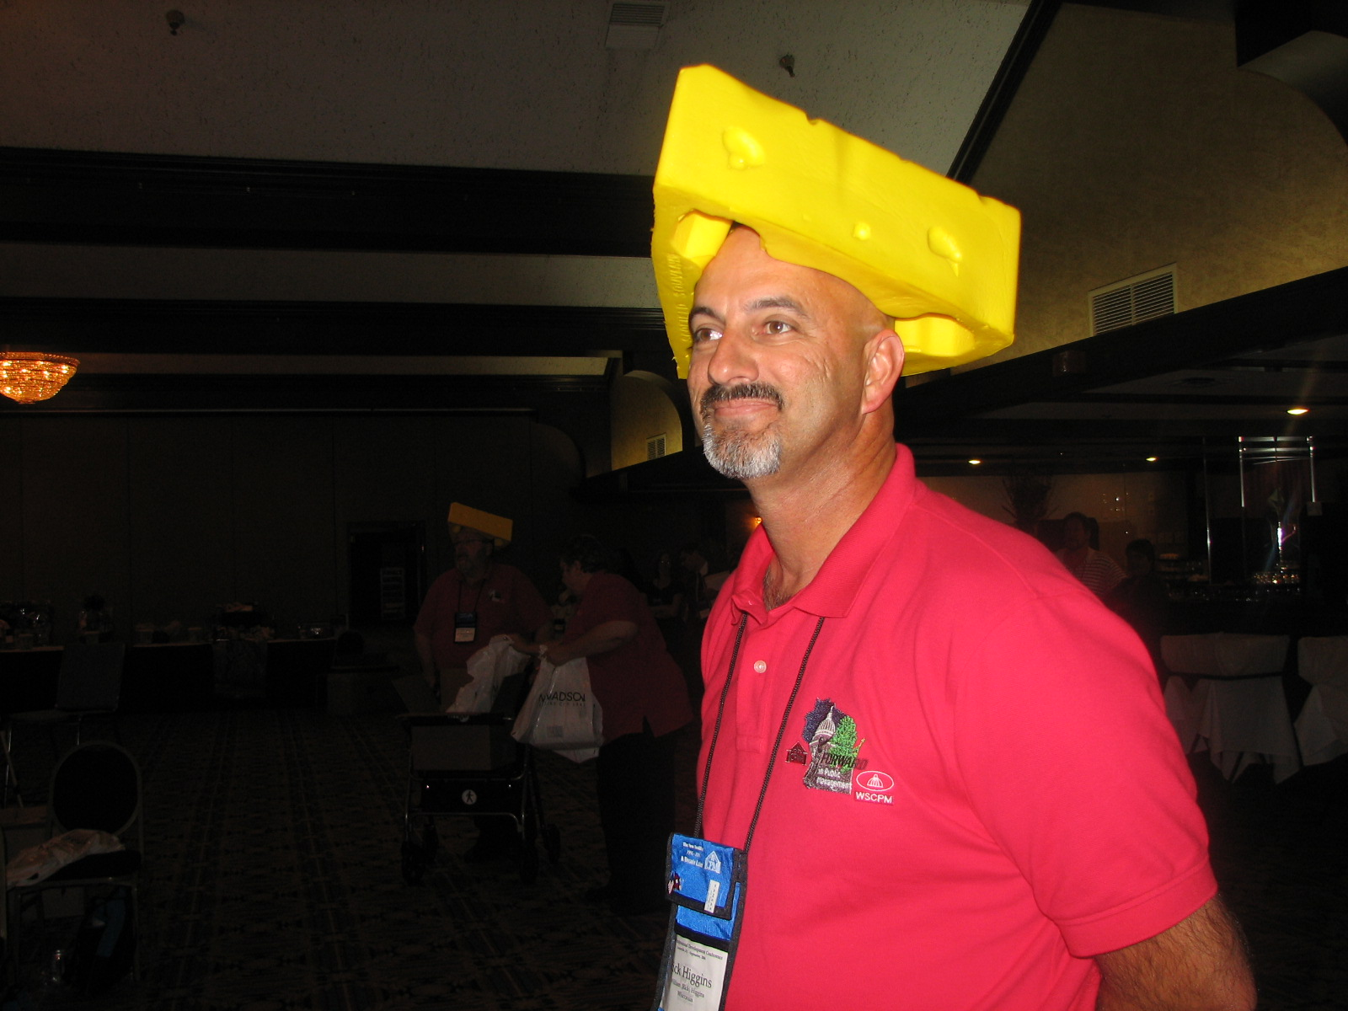

To ensure you can join us and participate, we need you to know how important it is to reserve your lodging now! On Sunday, Sept. 9, 2007 over 20,000 people will be in Madison to watch the IronMan and hotels are quickly filling their reservations for that weekend and into the early part of the following week. To ensure you get a room, you should book now. This will also ensure you have the chance to spend a little time in Madison, see the IronMan yourself and participate in many of the other special events we have scheduled before our conference starts!

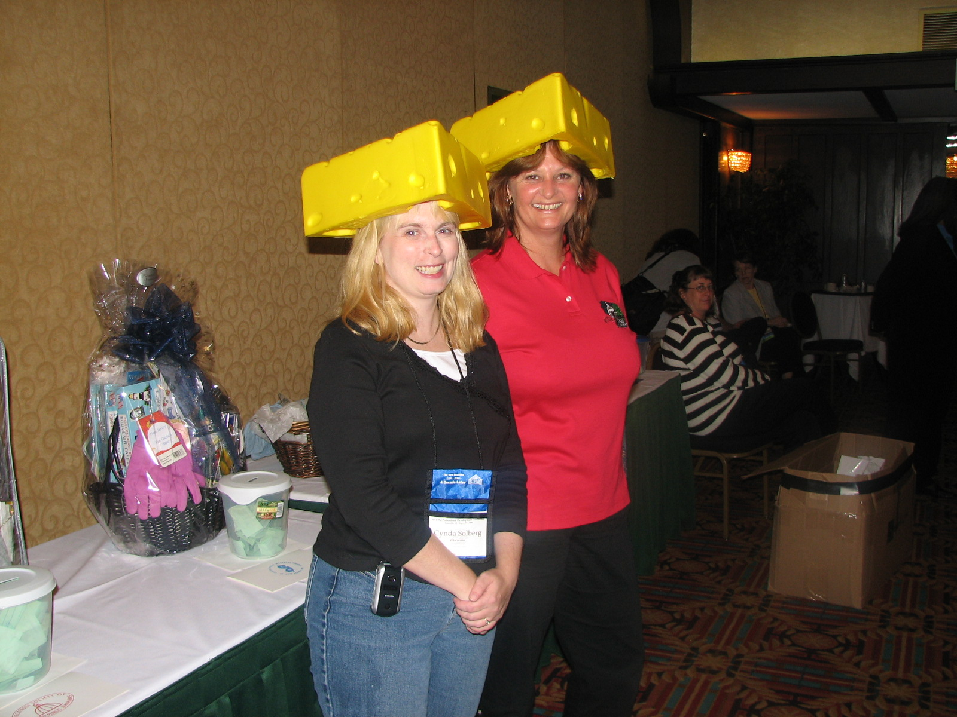

To make room reservations, call 1-800-356-8293, ask Reservations for the AACPM block. (You can charge lodging to a credit card over the phone.) You will NOT be billed until the conference. You can change payment plans upon arrival, and you can cancel with no charge until 24 hours before scheduled arrival (4 pm the day before).

Register on-line at: http://www.bondsconsulting.com/registration/

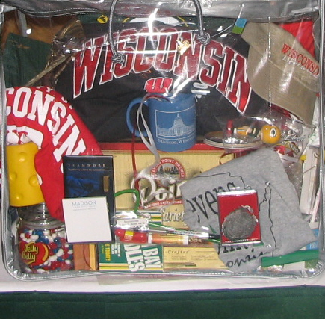

2006 Financial Report

 | BUDGET |  | INCOME
Member Dues | 4550.00 |  | $4,805.00
Lunch Income | 600.00 |  | $378.50
Product Income | 100.00 |  | $545.00
Bank Interest | 50.00 |  | $38.53
Reimbursement of CD | 2081.60 |  | $2,081.60
Misc Income |  |  | $4,321.44
 |  |  | TOTAL INCOME | $12,170.07
 | BUDGET |  | EXPENSES
AACPM Dues | (1800.00) |  | $1,620.00
Lunch Expense | (900.00) |  | $1,009.37
Website | (1200.00) |  | $975.00
AACPM Coalition | (200.00) |  | $100.00
Awards & Honors | (800.00) |  | $948.90
Print & Postage | (600.00) |  | $323.32
Misc Expense | (500.00) |  | $720.78
 |  |  | TOTAL EXPENSES | $5,697.37
 |  |  | NET INCOME |  | $6,472.70
 |  |  | BEGINNING BALANCE |  | $4,424.98
 |  |  | ENDING BALANCE |  |  | $10,897.68

Submitted by Carmen Bishop.

Kentucky Society Year 2007 Calendar – Dates to Remember

Kentucky Certified Public Manager® Graduation – April 3, 2007
Civic Center, Frankfort, KY

Annual Seminar – May 1, 2007,
Kentucky History Center, Frankfort, KY

Summer Luncheon – July, 2007
Department of Criminal Justice Training, EKU, Richmond, KY

AACPM Professional Development Conference – September 9-11, 2007
Madison, WS

Fall Luncheon – October, 2007
Date & Location TBA, Frankfort, KY

KSCPM Annual Membership Meeting – December 4, 2007
Kentucky Higher Education Assistance Authority Bldg – Frankfort, KY

The mission of the Kentucky Society of Certified Public Managers is to establish, promote, enhance, and recognize the management profession through comprehensive training, networking, professional growth, and ethical standards of behavior; to promote service consistent with efficient and effective management practices; and to demonstrate vision and competence in professional management.

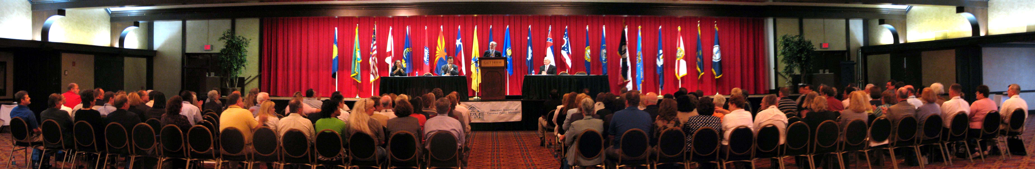
Photo from American Academy of Certified Public Managers® 18th Annual Professional Development Conference in downtown Louisville, Kentucky.

KSCPM 2007 BOARD OF DIRECTORS

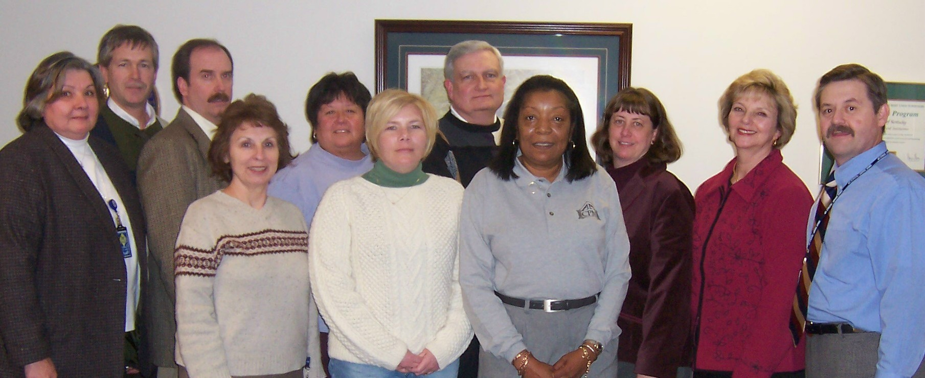
(L-R) Brenda Crosman, Robert Armstrong, Tony Smith, Helen Koger, Jeanne Olivas, Rebecca Conley, Larry Totten, Robinil Jameson, Carmen Bishop, Janice Earnest, Sherman Bowman (Absent from photo: Doug Holt, Katy Cave, Pamla Wood.)

Robinil H. Jameson | President | RHJCPM@aol.com | 502-875-5466
Tony Smith | President-Elect | tonyb.smith@ky.gov | 502-564-4319
Helen Koger | Secretary | helen.koger@ky.gov | 859-622-3801
Carmen Bishop | Treasurer | carmen.bishop@ky.gov | 502-573-3390
Larry P. Totten | Immediate Past President | larry.totten@ky.gov | 270-343-2449
Jeanne Olivas | OEOD Liaison | jeanne.olivas@ky.gov | 502-564-8170
Janice Earnest | Election Committee | janice.earnest@ky.gov | 859-622-8062
Katy Cave | Program Committee | Katy.cave@ky.gov | 502-564-8170
Douglas Holt | Publications & Publicity Committee | douglas.holt@ky.gov | 502-564-6746
Rebecca Conley | Membership Committee | rebecca.conley@ky.gov | 502-573-3390
Robert Armstrong | Finance Committee | robert.armstrong@ky.gov | 502-245-9091
Larry P. Totten | Awards Committee | larry.totten@ky.gov | 270-343-2449
Special Appointed Committees
Sherman Bowman | Legislative Committee | sherman.bowman@ky.gov | 502-564-7000  Ext. 4172
Janice Earnest | Historian & Archivist | janice.earnest@ky.gov | 859-622-8062
Janice Earnest  Robinil H. Jameson | Standard Operating Procedures | janice.earnest@ky.gov  RHJCPM@aol.com | 859-622-8062  502-875-5466
KSCPM | Web Page | http://www.KSCPM.org | POB 42  Frankfort, KY  40602-0042
AACPM | Web Page | http://www.cpmacademy.org

2007 KSCPM PROFESSIONAL SEMINAR


May 1, 2007 - Tuesday - 8:30 a.m. - 4:00 p.m.

Thomas D. Clark Center for Kentucky History

100 W. Broadway, Frankfort, Kentucky

TOPIC: "Management: Visions and Opportunities
Shifting in the Workplace"

Registration Form:

Name_______________________________________________Title______________________________________________

Organization____________________________________________________________________

Address________________________________________________________________________

City________________________________State____________________Zip________________

Telephone_________________________________Fax__________________________________

E-mail_________________________________________________________________________

Registration Fee: $75 Members $100 Non-Members

- Registration Fee includes materials, breaks and luncheon.
- Registration with payment must be received by Tuesday, April 24.
- We cannot accept credit cards or inter-accounts. Vendor # 58-1779206
- No refunds, but substitutions are permitted.
- Five hours CPE credit will be given for this seminar.

Mail Registrations with Payment to: | MESSENGER MAIL to:
KSCPM Professional Seminar  P. O. Box 42  Frankfort, Kentucky 40602-0042 | Carmen Bishop, Compliance Branch Manager  Dept. of Financial Institutions  1025 Capital Center Dr., Suite 200  Frankfort, KY 40601

The Cutting Edge  KSCPM Newsletter  P. O. Box 42  Frankfort, KY 40602-0042 |  | POSTAGE
ADDRESS CORRECTION REQUESTED

